



***Database Management System project***

***IS 221T***

Hotel Booking Management Database System

|  |  |  |
| --- | --- | --- |
| Percentage for work | ID | Students Name |
| 20% | 439004432 | Fai Almoqbel |
| 20% | 439001090 | Maha Alhazzani |
| 20% | 439004608 | Munira Bin munif |
| 20% | 439002761 | Raghad Altoum |
| 20% | 439004497 | Sara Alsubaie |
| 20% | 439000792 | Nada Alhotan |

T.Anfal Alqhatani

Section 7W1

November 2021

***Table of Contents***

Project Description 3

DBA’s Role 3

ER-Diagram of the Database 4

Mapping 5

Creation of User, Tablespace, Index 6

Creation of Tables 7

Creation of Function 21

Creation of Triggers 23

User Interfaces 25

***Project Description:***

Booking hotels is one of the most important needs of people in travel and housing nowadays.

Our goal in this project is to design the hotel system effectively in terms of hotel, customer, and employee as well. In addition, allowing the hotel to count all its branches, employees, customers, and their management. As well as the ability of the customer to reserve, modify and delete rooms, etc. It also allows the employee to service and manage the hotel, for example, the manager employee can count the number of rooms that have been operated, and so on.

In our system, we provide everything a hotel, customer and employee needs to facilitate and deliver services effectively.

***DBA’s role:***

The prime responsibility of DBA is to manage, secure, and take care of the DBMS and other responsibilities like controlling, maintenance, coordinating, and operation of DBMS. That can be done by accomplishing duties like:

* Managing data integrity and security.
  + By restricting data from unauthorized users using GRANT.
  + Enforcing policies, procedures, and standards for creation, usage, and distribution of data which will ensure correctness of data therefore ensuring integrity.
* Ensuring users security.
  + By setting an expiring their passwords using PASSWORD EXPIRE.
  + Giving the right permissions to the right people, especially the "grant option"
* Query processing performance.
* Tuning database performance.
* Designing database backup, archiving, and storage strategy .

***ERD:***

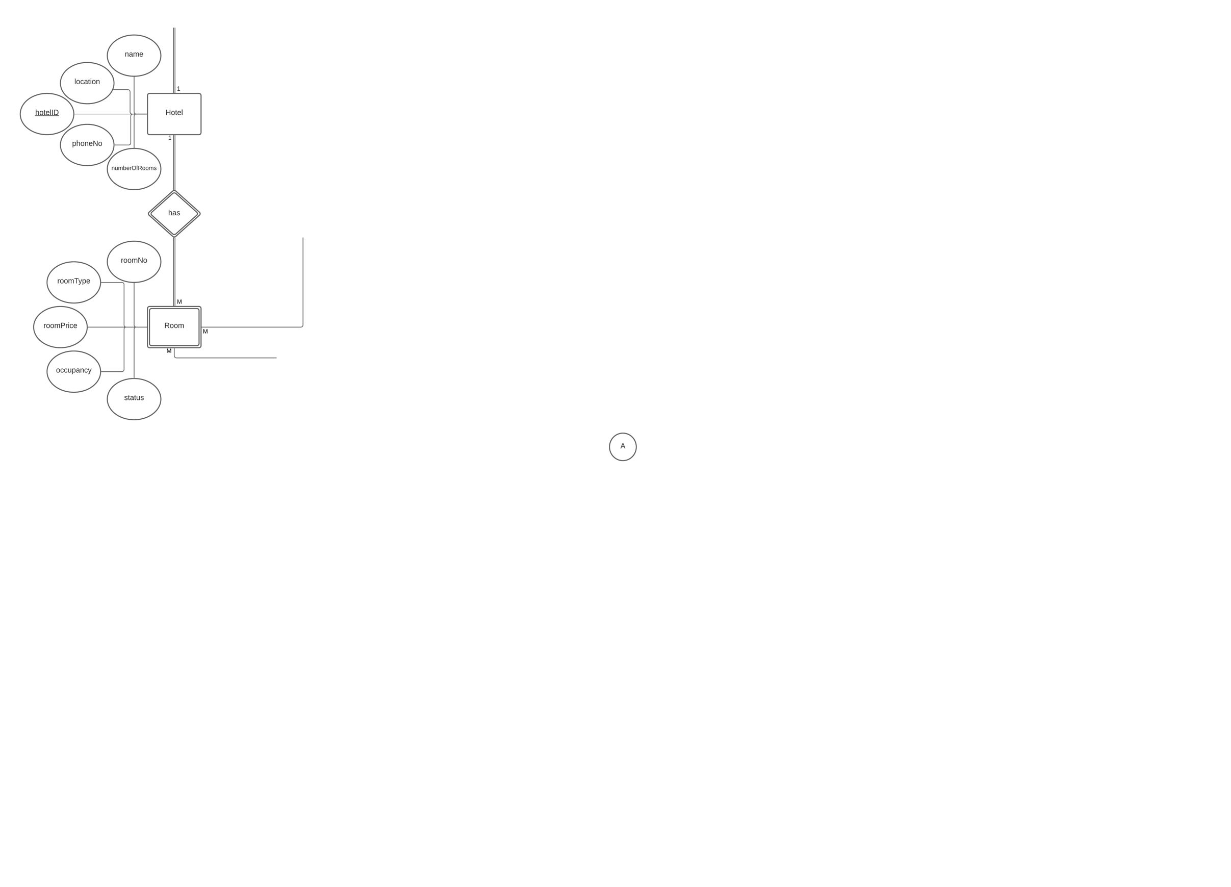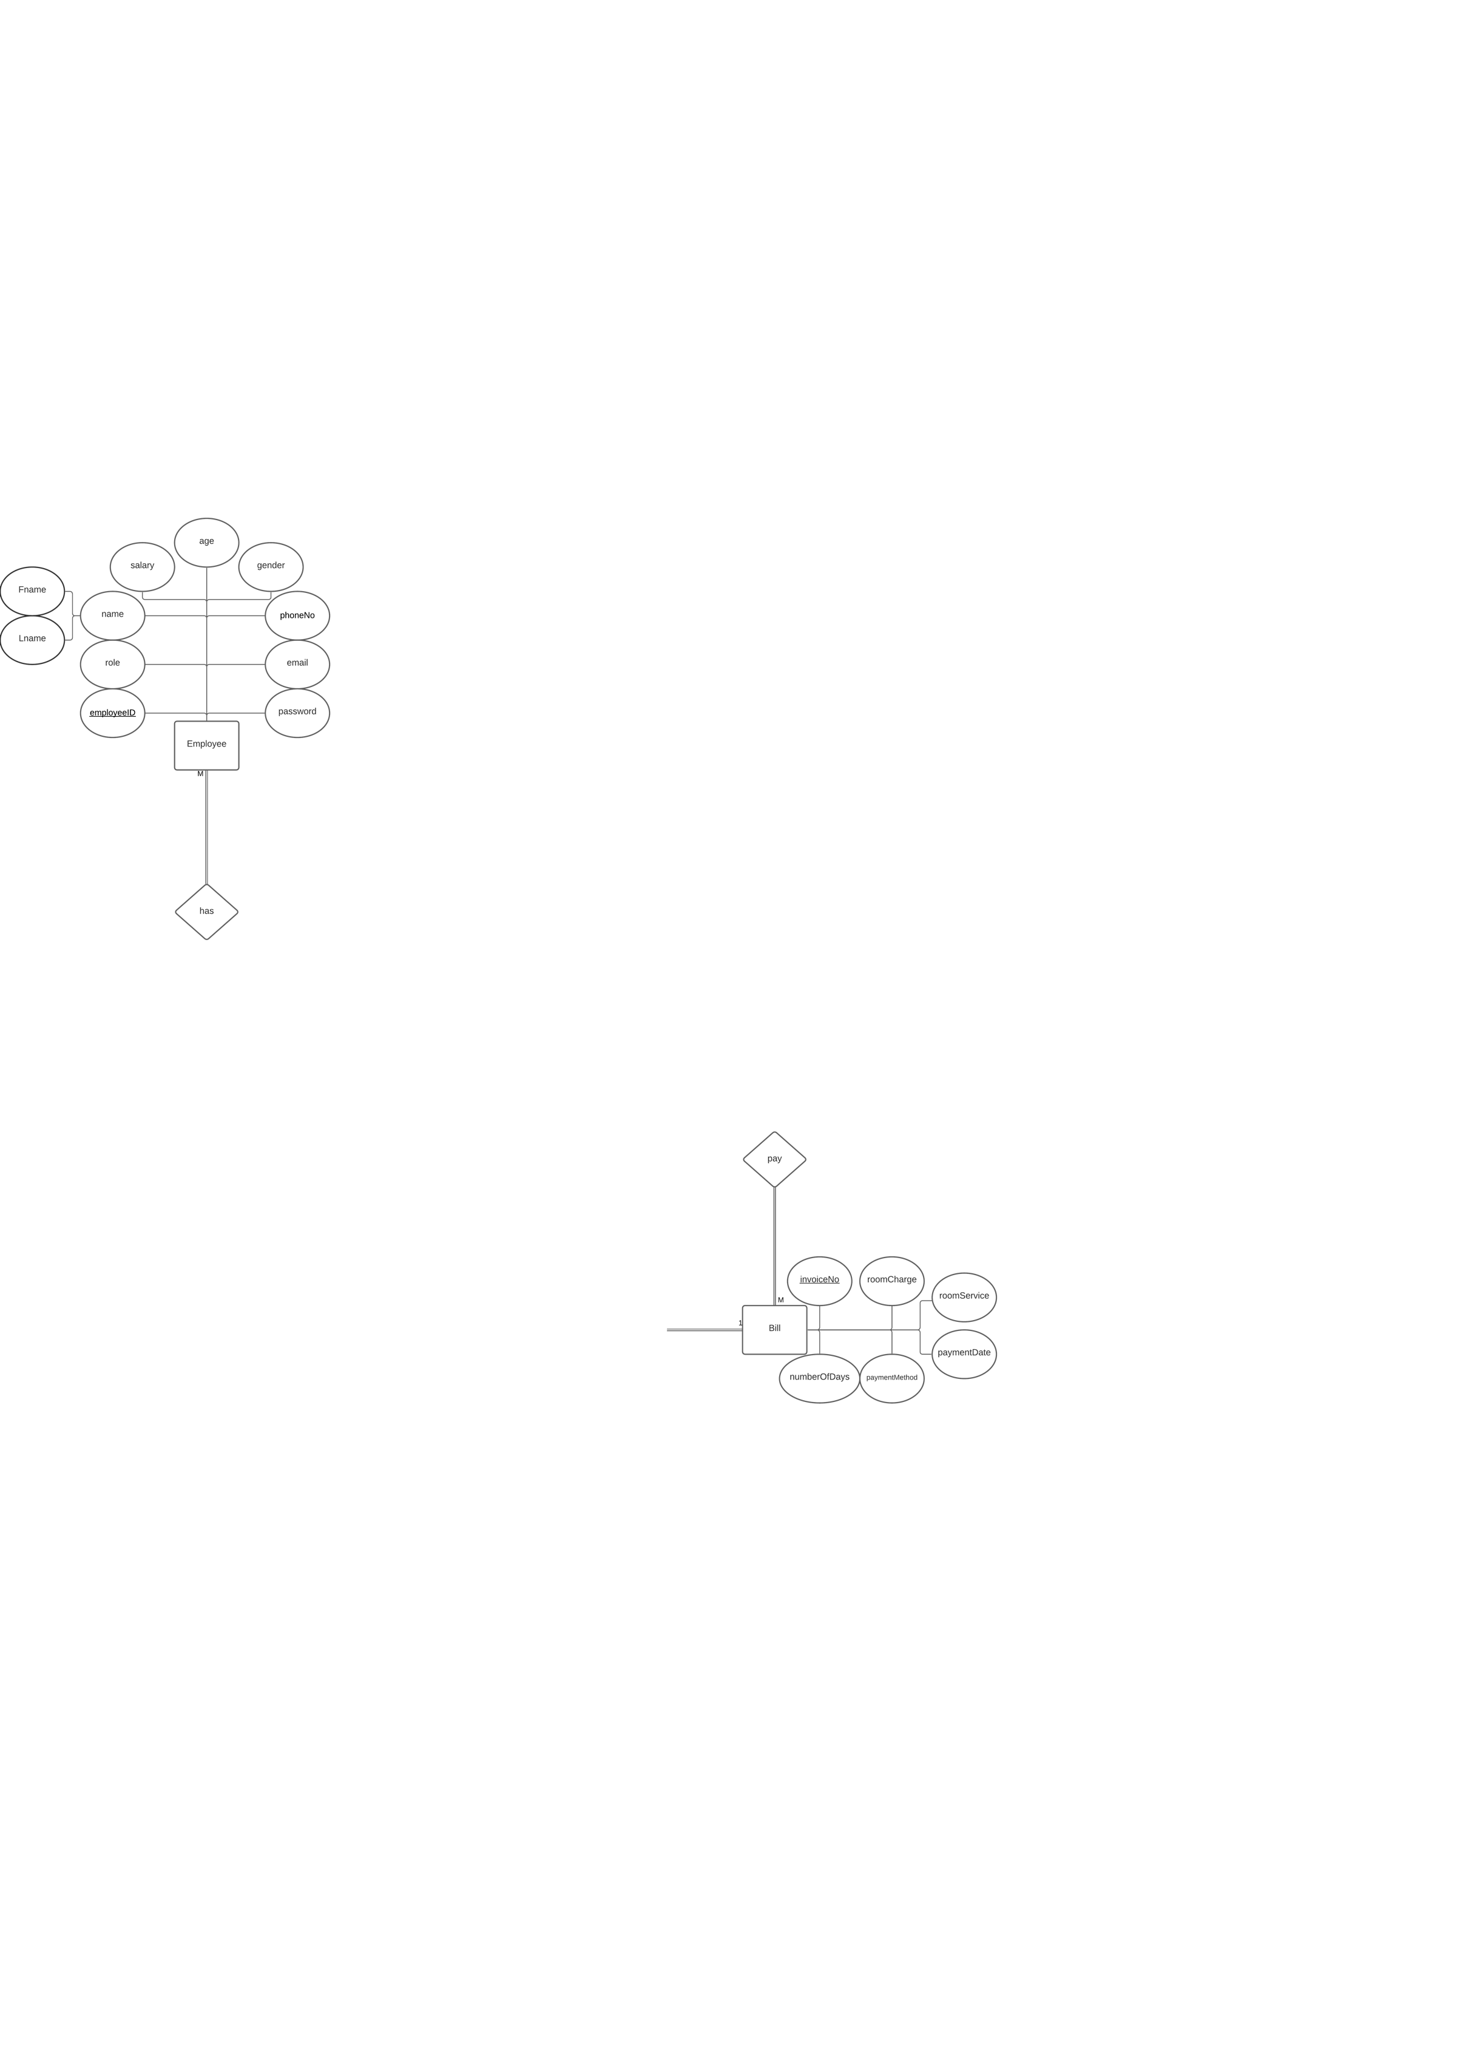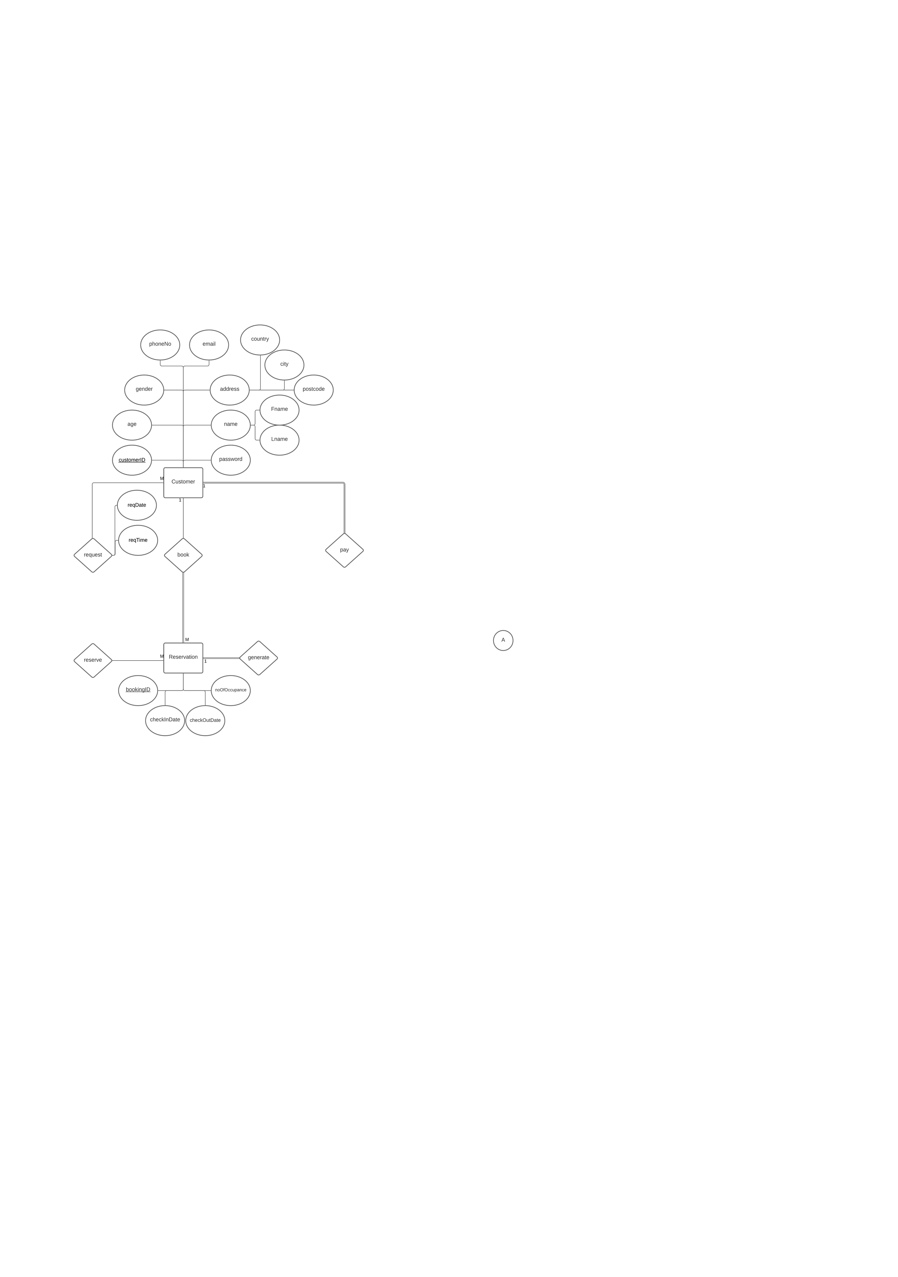

***The description of our diagram:***

Each hotel contains many employees and rooms, each employee can only belong to one hotel, customers can book one or more rooms at different prices and types, customer can make many reservations and pay using different payment methods. Each reservation has one. Each room can be reserved by many reservations.

***Map ER diagram to tables:***

**Hotel** (**hotelID**, location, name, phoneNo, numberOfRooms)  
——————  
**Employee**(**employeeID**, role, Fname, Lname, salary, DoB, gender, phoneNo, email, password, hotelID)  
**Fk:** hotelID references Hotel(hotelID)  
——————  
**Room**(**roomNo**,bookingID,**hotelID**,roomType,roomPrice,occupancy,status, customerID)  
**Fk:** hotelID references Hotel(hotelID)  
**Fk:** bookingID references Reservation(bookingID)  
**Fk:** customerID references Customer(customerID)  
——————  
**Customer** (**customerID** ,DoB, gender ,phoneNo , email, password , country ,city, postcode ,Fname ,Lname)   
———————  
**Bill** (**invoiceNo** ,roomCharge , roomService , paymentDate , paymentMethod, numberOfDays ,customerID , bookingID)  
**Fk:** customerID references Customer(customerID)  
**Fk:** bookingID references Reservation(bookingID)  
———————  
**Reservation** (**bookingID**, checkInDate,c heckOutDate, noOfOccupance, customerID)  
**Fk:** customerID references Customer(customerID)  
———————

**Request** (reqDate, reqTime, customerID, (roomNo ,hotelId ) )

**Fk:** customerID references Customer(customerID)

**Fk:** hotelID_roomNo_Request references Room(roomNo ,hotelId)

———————

**Reserve** (bookingID, (roomNo ,hotelId) )

**Fk:** bookingID references Reservation(bookingID)  
**Fk:** hotelID_roomNo_Reserve references Room(roomNo ,hotelId)

***Creation of User: (DBA’s Role)***

Create user Fai identified by ffff;

Grant Connect to Fai ;

Grant all privileges to Fai ;

alter user Fai default tablespace Employee_tablespace ;

select username ,default_tablespace from dba_users where username = 'Fai';

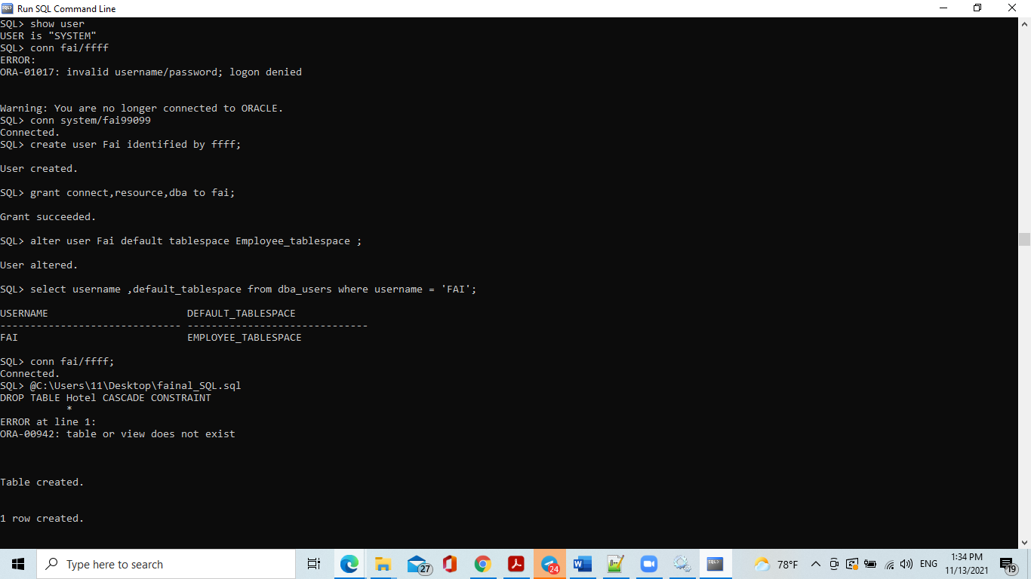

***Creation of Tablespace: (DBA’s Role)***

drop tablespace Employee_tablespace including contents and datafiles;

create tablespace Employee_tablespace datafile 'Employee' size 250m;

alter tablespace Employee_tablespace read only;

drop tablespace Room_tablespace including contents and datafiles;

create tablespace Room_tablespace datafile 'Room' size 30m;

alter tablespace Room_tablespace read only;

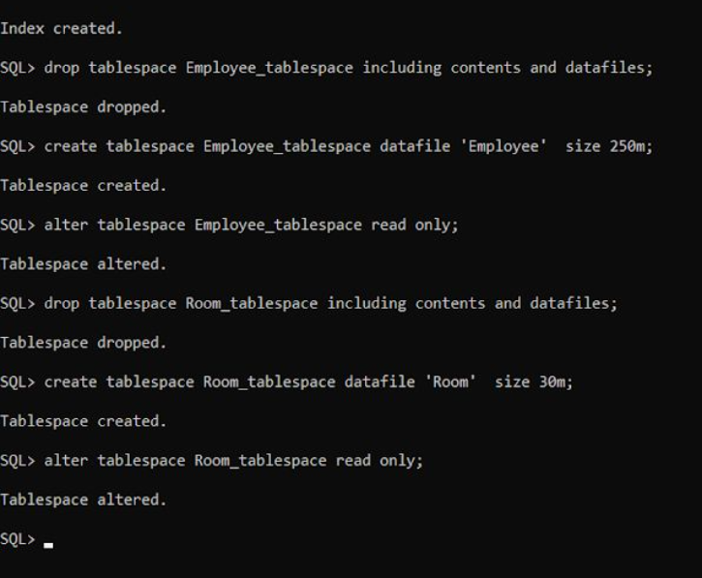

***Creation of Index:***

DROP INDEX Customer_index ;

CREATE INDEX Customer_index ON Customer(upper (city));

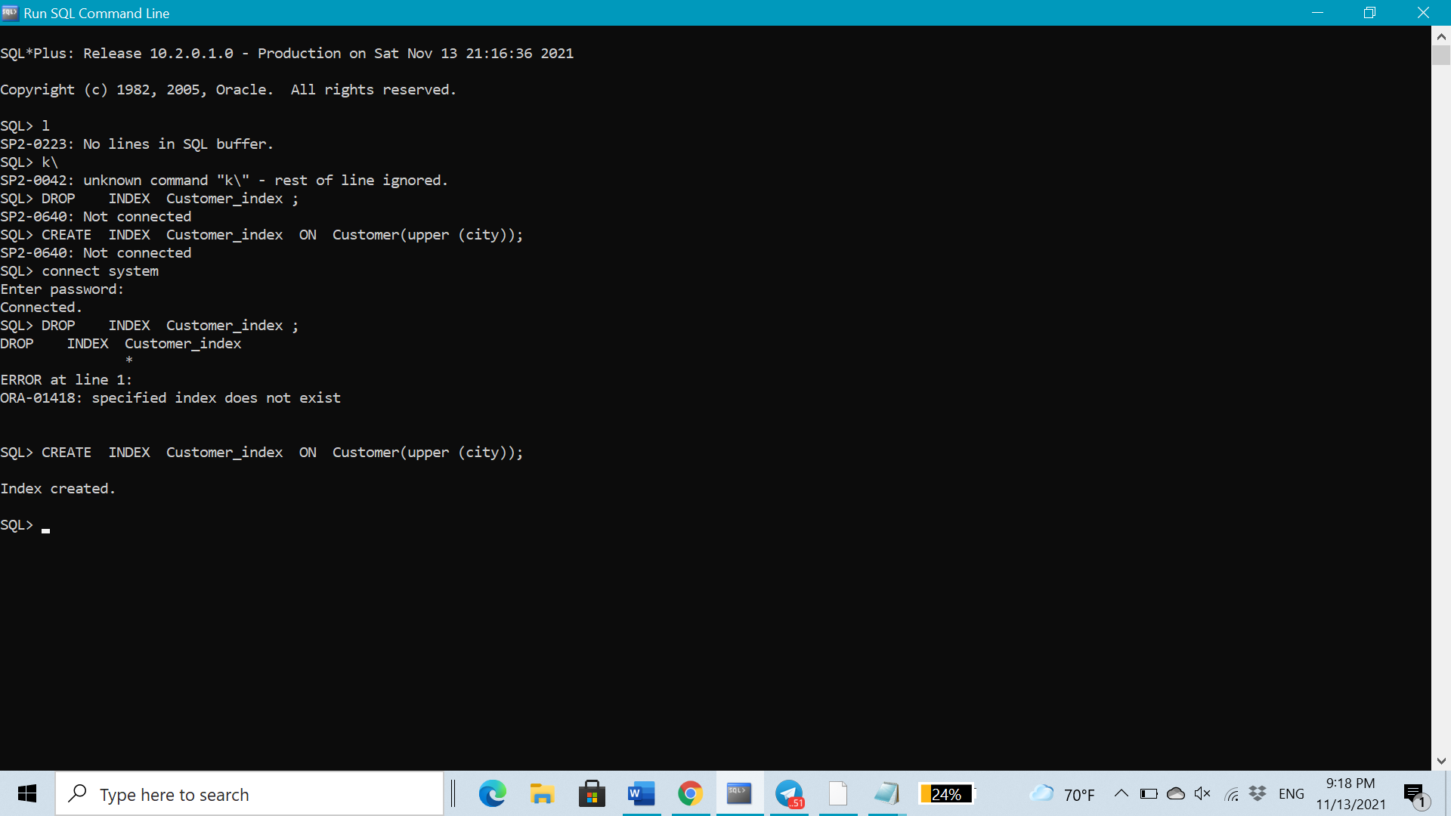

***Creation of tables:***

* ***Hotel Table***

DROP TABLE Hotel CASCADE CONSTRAINT;

CREATE TABLE **Hotel** (

hotelID VARCHAR2 (5),

lacation VARCHAR2(200),

name VARCHAR2(40),

phoneNo NUMBER(10) UNIQUE,

numberOfRooms NUMBER(3),

CONSTRAINT hotelID_Htl PRIMARY KEY(hotelID)

);

INSERT INTO Hotel VALUES('ht01','Riyadh','RiyBranch', 0114441111, 50);

INSERT INTO Hotel VALUES('ht02','Dammam','DamBranch', 0134431111, 30);

INSERT INTO Hotel VALUES('ht03','Jeddah','JedBranch', 0124421111, 40);

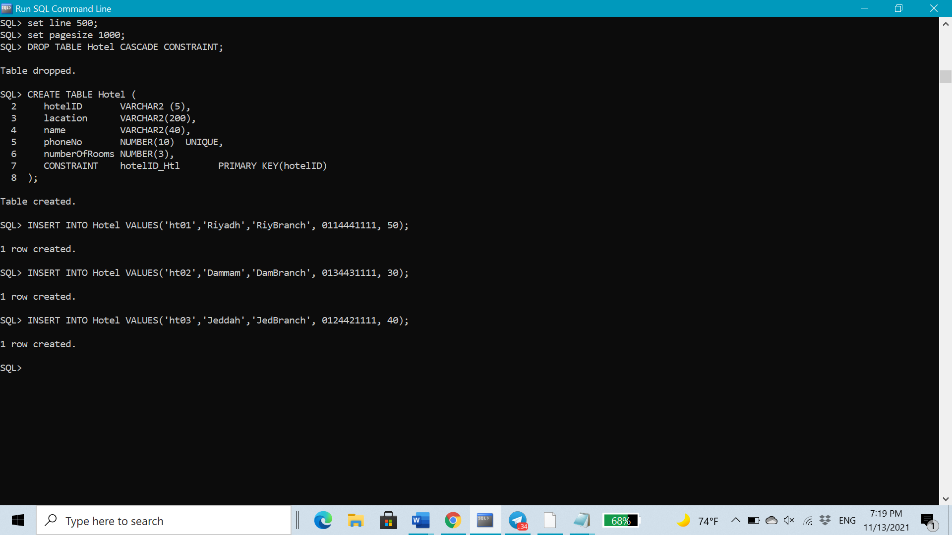

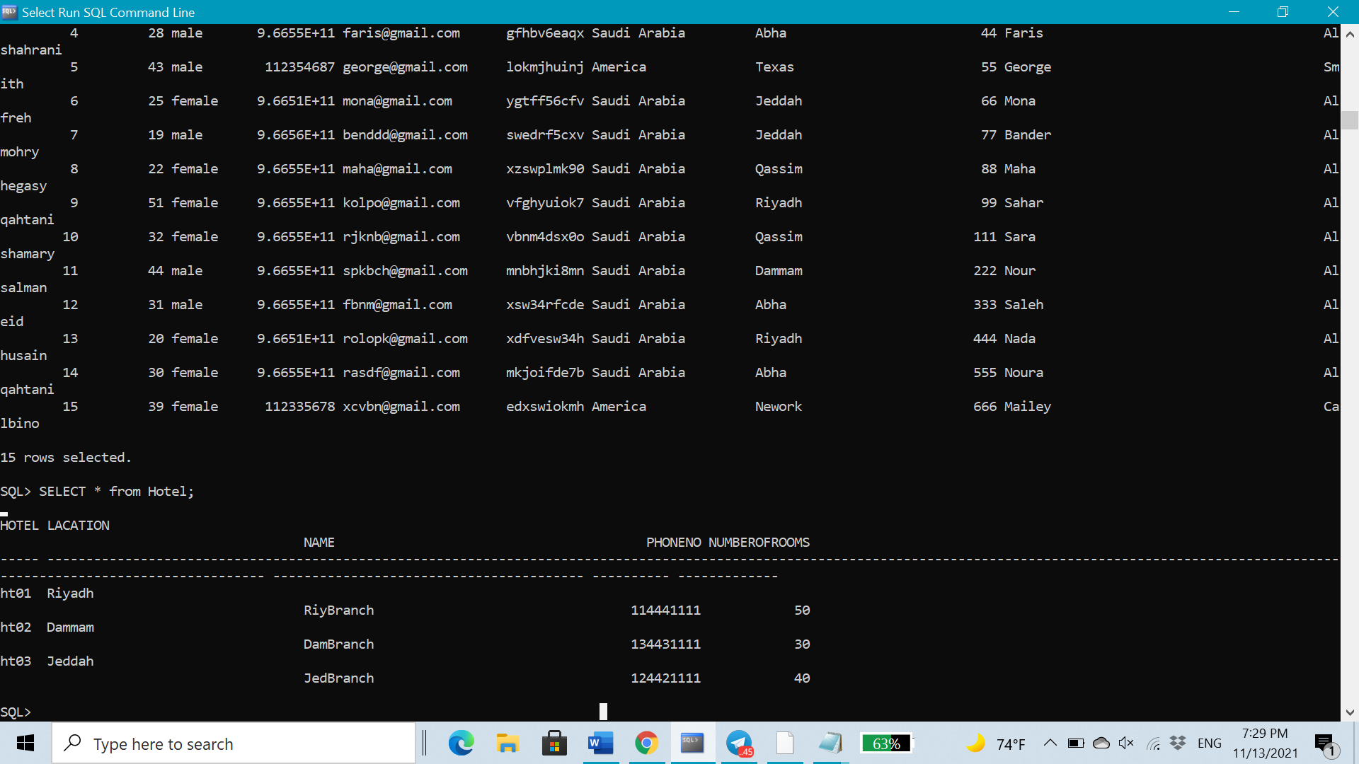

* ***Customer Table***

DROP TABLE Customer CASCADE CONSTRAINT;

CREATE TABLE **Customer** (

customerID NUMBER (5),

Age NUMBER(2),

gender VARCHAR2(10),

phoneNo NUMBER(12) UNIQUE NOT NULL,

email VARCHAR2(20) UNIQUE NOT NULL,

password VARCHAR2(10) NOT NULL,

country VARCHAR2(20),

city VARCHAR2(20),

postcode NUMBER(5),

Fname VARCHAR2(40),

Lname VARCHAR2(40),

CONSTRAINT customerID_Cstmr PRIMARY KEY(customerID));

INSERT INTO Customer VALUES (00001, 20, 'female', 966556778901, 'roro@gmail.com', 'f6tgjklop8', 'Saudi Arabia', 'Riyadh', 00011, 'Raghad', 'Altoum');

INSERT INTO Customer VALUES (00002, 46, 'female', 966556780454, 'rahaf@gmail.com', 'ghm7inbb9y', 'Saudi Arabia', 'Riyadh', 00022, 'Rahaf', 'Alobied');

INSERT INTO Customer VALUES (00003, 35, 'male', 966506678964, 'salim@gmail.com', 'gftyui8bnj', 'Saudi Arabia', 'Dammam', 00033, 'Mohammed', 'Alfahad');

INSERT INTO Customer VALUES (00004, 28, 'male', 966553435677, 'faris@gmail.com', 'gfhbv6eaqx', 'Saudi Arabia', 'Abha', 00044, 'Faris', 'Alshahrani');

INSERT INTO Customer VALUES (00005, 43, 'male', 0112354687, 'george@gmail.com', 'lokmjhuinj', 'America', 'Texas', 00055, 'George', 'Smith');

INSERT INTO Customer VALUES (00006, 25, 'female', 966507933088, 'mona@gmail.com', 'ygtff56cfv', 'Saudi Arabia', 'Jeddah', 00066, 'Mona', 'Alfreh');

INSERT INTO Customer VALUES (00007, 19, 'male', 966556563480, 'benddd@gmail.com', 'swedrf5cxv', 'Saudi Arabia', 'Jeddah', 00077, 'Bander', 'Almohry');

INSERT INTO Customer VALUES (00008, 22, 'female', 966553564224, 'maha@gmail.com', 'xzswplmk90', 'Saudi Arabia', 'Qassim', 00088, 'Maha', 'Alhegasy');

INSERT INTO Customer VALUES (00009, 51, 'female', 966552265656, 'kolpo@gmail.com', 'vfghyuiok7', 'Saudi Arabia', 'Riyadh', 00099, 'Sahar', 'Alqahtani');

INSERT INTO Customer VALUES (00010, 32, 'female', 966553546765, 'rjknb@gmail.com', 'vbnm4dsx0o', 'Saudi Arabia', 'Qassim', 00111, 'Sara', 'Alshamary');

INSERT INTO Customer VALUES (00011, 44, 'male', 966554657898, 'spkbch@gmail.com', 'mnbhjki8mn', 'Saudi Arabia', 'Dammam', 00222, 'Nour', 'Alsalman');

INSERT INTO Customer VALUES (00012, 31, 'male', 966553565189, 'fbnm@gmail.com', 'xsw34rfcde', 'Saudi Arabia', 'Abha', 00333, 'Saleh', 'Aleid');

INSERT INTO Customer VALUES (00013, 20, 'female', 966506788984, 'rolopk@gmail.com', 'xdfvesw34h', 'Saudi Arabia', 'Riyadh', 00444, 'Nada', 'Alhusain');

INSERT INTO Customer VALUES (00014, 30, 'female', 966554678907, 'rasdf@gmail.com', 'mkjoifde7b', 'Saudi Arabia', 'Abha', 00555, 'Noura', 'Alqahtani');

INSERT INTO Customer VALUES (00015, 39, 'female', 0112335678, 'xcvbn@gmail.com', 'edxswiokmh', 'America', 'Nework', 00666, 'Mailey', 'Calbino');

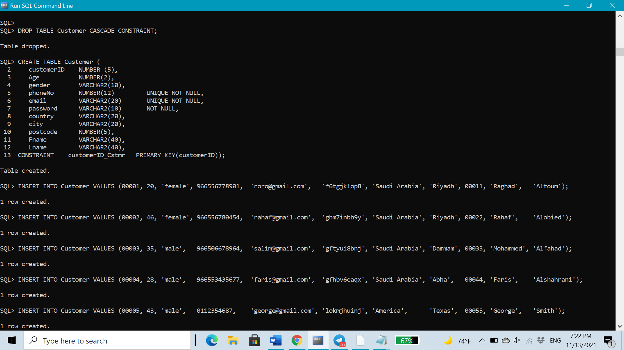

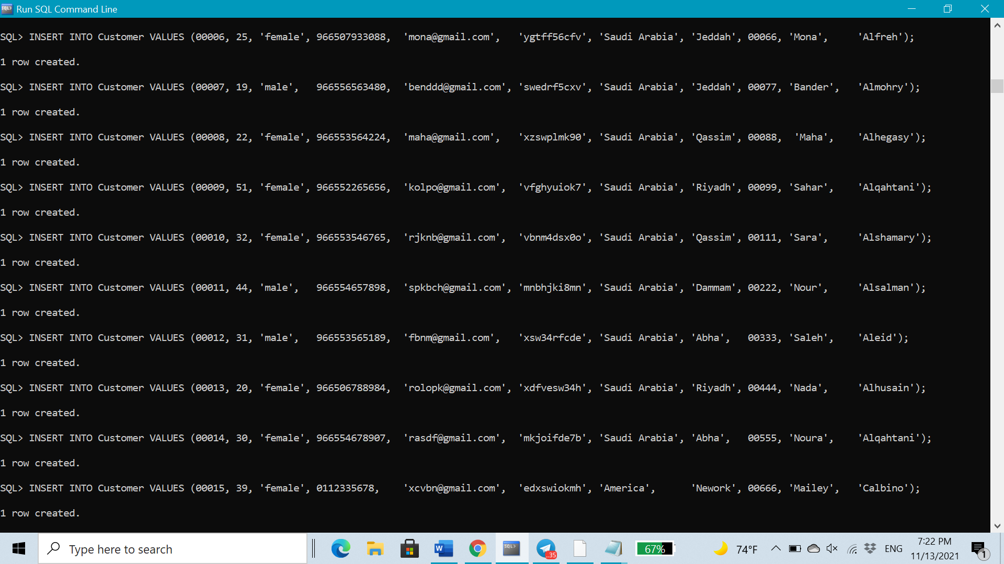

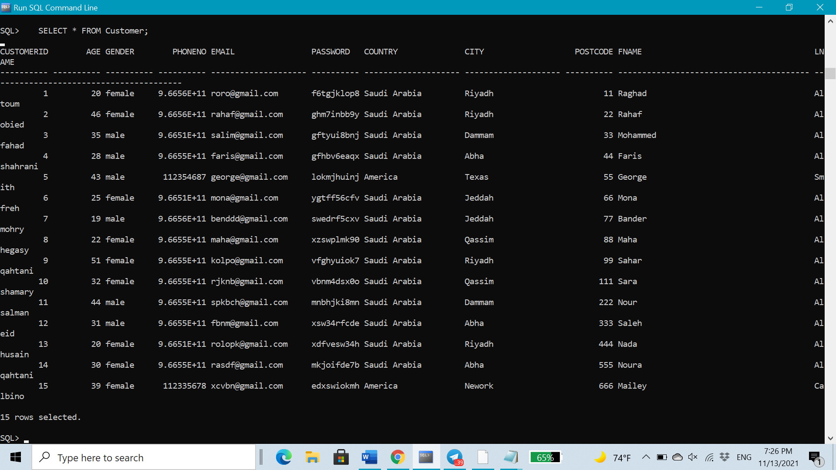

* ***Employee Table***

DROP TABLE Employee CASCADE CONSTRAINT;

CREATE TABLE **Employee** (

employeeID NUMBER (5),

role VARCHAR2(20),

Fname VARCHAR2(40),

Lname VARCHAR2(40),

salary NUMBER(5),

phoneNo NUMBER(12) UNIQUE NOT NULL,

Age NUMBER(2),

email VARCHAR2(30) UNIQUE NOT NULL,

password VARCHAR2(30) NOT NULL,

hotelID VARCHAR2 (5),

CONSTRAINT employeeID_Emp PRIMARY KEY(employeeID),

CONSTRAINT hotelID_Emp FOREIGN KEY (hotelID) REFERENCES Hotel(hotelID));

INSERT INTO Employee VALUES(11001,'staff', 'Ahmad', 'Ali', 6000,'966554009852','25','ahmad@hotmail.com', 'uslwfpua88', 'ht01');

INSERT INTO Employee VALUES(11002,'manager','Noura', 'Saad', 7000,'966551134266','30','NouraS@hotmail.com', 'iyvqxzrq43', 'ht02');

INSERT INTO Employee VALUES(11003,'manager','Mohammed', 'Faisal', 7500,'966505897987','33','Mohammed@hotmail.com', 'aufvxyuy57', 'ht01');

INSERT INTO Employee VALUES(11004,'staff', 'Sara', 'Ahmad', 6500,'966555519808','24','Sara@hotmail.com', 'juhktin877', 'ht02');

INSERT INTO Employee VALUES(11005,'staff', 'Abdullah', 'Mohammed', 6000,'966533889769','26','Abdullah@hotmail.com', 'qwerty8976', 'ht03');

INSERT INTO Employee VALUES(11006,'manager','Abdulaziz','Abdullah', 7000,'966533880000','31','aziz@hotmail.com', 'mwehdjw976', 'ht03');

INSERT INTO Employee VALUES(11007,'staff', 'Ibrahim', 'Mohammed', 5500,'966553880009','27','Ibrahim@hotmail.com', 'jwerhgk98', 'ht03');

INSERT INTO Employee VALUES(11008,'staff', 'Arwa', 'Ibrahim', 6500,'966530009769','28','Arwa@hotmail.com', 'hwretfhjn6', 'ht02');

INSERT INTO Employee VALUES(11009,'staff', 'shadah', 'Mohammed', 5000,'966533882009','24','shadah@hotmail.com', 'rwexcvv676', 'ht03');

INSERT INTO Employee VALUES(11010,'staff', 'saud', 'abdulaziz',5000,'966534888000','26','saud@hotmail.com', 'mnjrty8840', 'ht03');

INSERT INTO Employee VALUES(11011,'staff', 'Reem', 'Saud', 6000,'966533883976','23','Reem@hotmail.com', 'mnjkljw976', 'ht02');

INSERT INTO Employee VALUES(11012,'staff', 'Lama', 'Nasser', 6000,'966553881243','25','Lama@hotmail.com', 'jweeuik98', 'ht01');

INSERT INTO Employee VALUES(11013,'staff', 'Ghadah', 'Saad', 6000,'966530787669','29','Ghadah@hotmail.com', 'hwretmkju6', 'ht01');

INSERT INTO Employee VALUES(11014,'staff', 'Afnan', 'Mohammed', 5500,'966533484809','24','Afnan@hotmail.com', 'rwexnhj876', 'ht03');

INSERT INTO Employee VALUES(11015,'staff', 'Nouf', 'Ahmad', 5500,'966549498000','25','Nouf@hotmail.com', 'mnjrty8mjk', 'ht01');

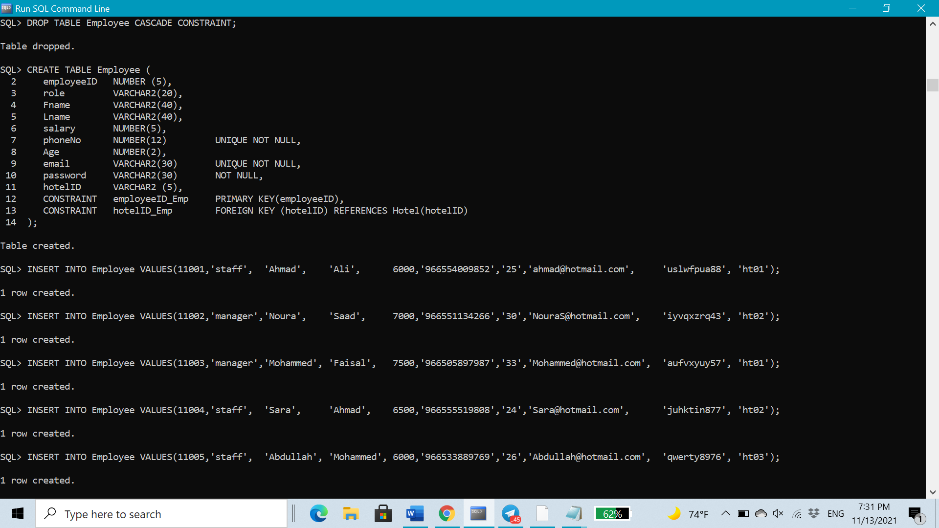

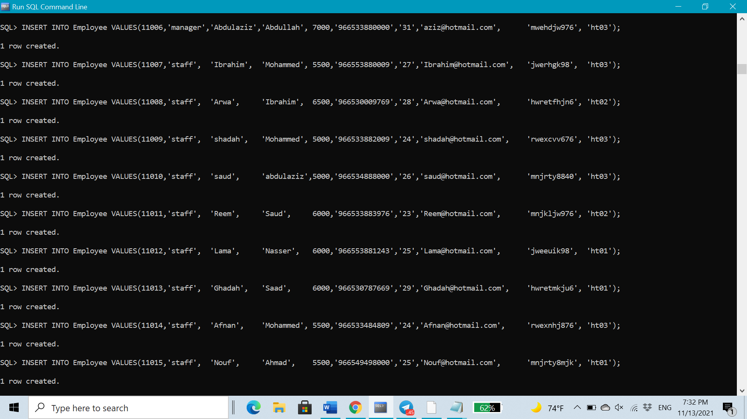

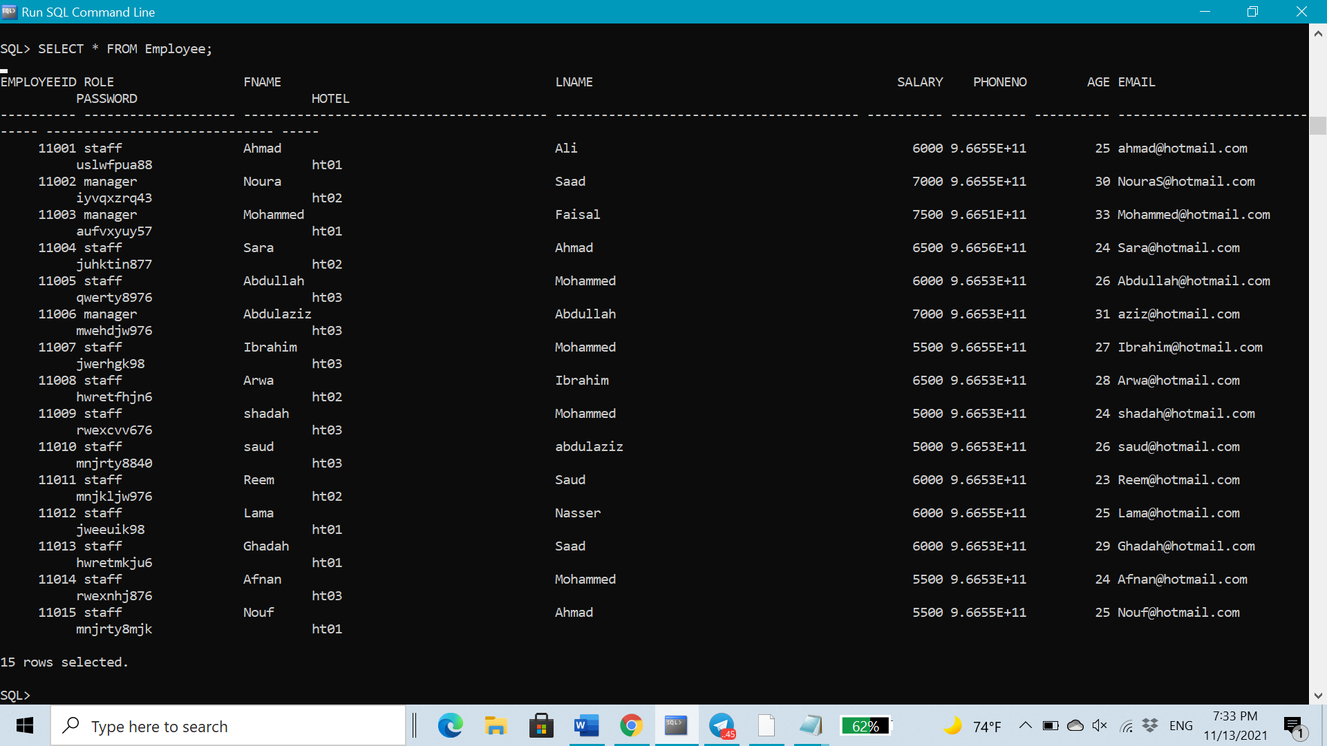

* ***Reservation Table***

DROP TABLE Reservation CASCADE CONSTRAINT;

CREATE TABLE **Reservation** (

bookingID NUMBER(5),

checkInDate DATE,

checkOutDate DATE,

noOfOccupance NUMBER(3),

customerID NUMBER,

CONSTRAINT bookingID_Res PRIMARY KEY(bookingID),

CONSTRAINT customerID_Res FOREIGN KEY (customerID) REFERENCES Customer(customerID)

);

INSERT INTO Reservation VALUES(10000, '22 nov 2020', '25 nov 2020', 3, 00001);

INSERT INTO Reservation VALUES(11000, '22 nov 2020', '24 nov 2020', 2, 00002);

INSERT INTO Reservation VALUES(11100, '24 nov 2020', '27 nov 2020', 4, 00003);

INSERT INTO Reservation VALUES(11110, '26 nov 2020', '29 nov 2020', 5, 00004);

INSERT INTO Reservation VALUES(11111, '01 dec 2020', '04 dec 2020', 3, 00005);

INSERT INTO Reservation VALUES(20000, '10 dec 2020', '15 dec 2020', 2, 00006);

INSERT INTO Reservation VALUES(22000, '10 dec 2020', '20 dec 2020', 8, 00007);

INSERT INTO Reservation VALUES(22200, '15 dec 2020', '17 dec 2020', 5, 00008);

INSERT INTO Reservation VALUES(22220, '20 dec 2020', '25 dec 2020', 6, 00009);

INSERT INTO Reservation VALUES(22222, '22 dec 2020', '25 dec 2020', 7, 00010);

INSERT INTO Reservation VALUES(30000, '24 dec 2020', '26 dec 2020', 8, 00011);

INSERT INTO Reservation VALUES(33000, '25 dec 2020', '26 dec 2020', 4, 00012);

INSERT INTO Reservation VALUES(33300, '10 jan 2021', '14 jan 2021', 3, 00013);

INSERT INTO Reservation VALUES(33330, '17 jan 2021', '29 jan 2021', 2, 00014);

INSERT INTO Reservation VALUES(33333, '11 jan 2021', '17 jan 2021', 1, 00015);

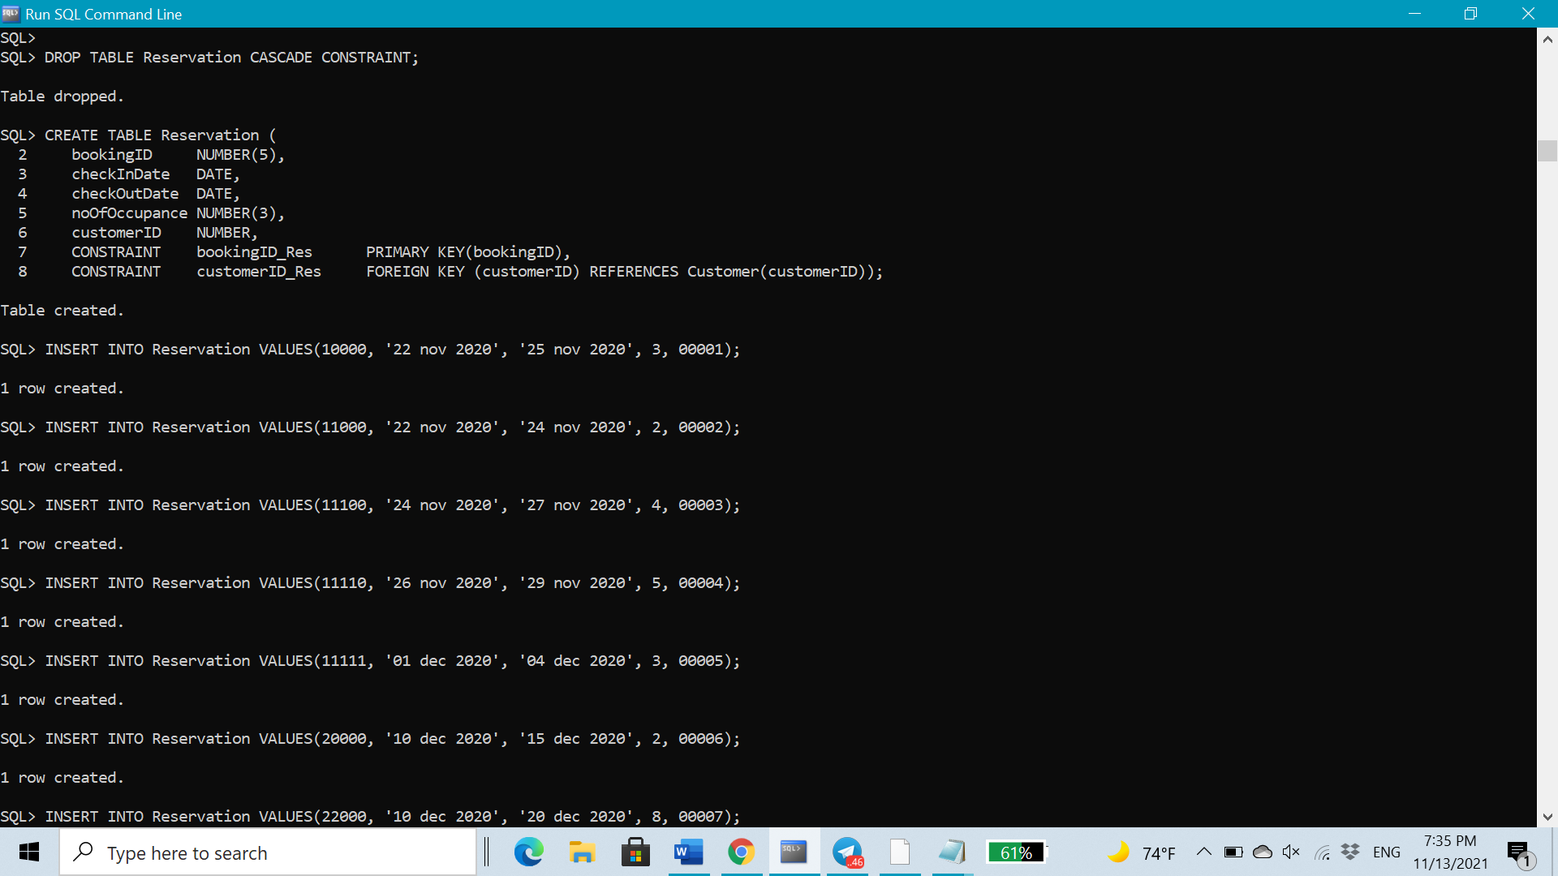

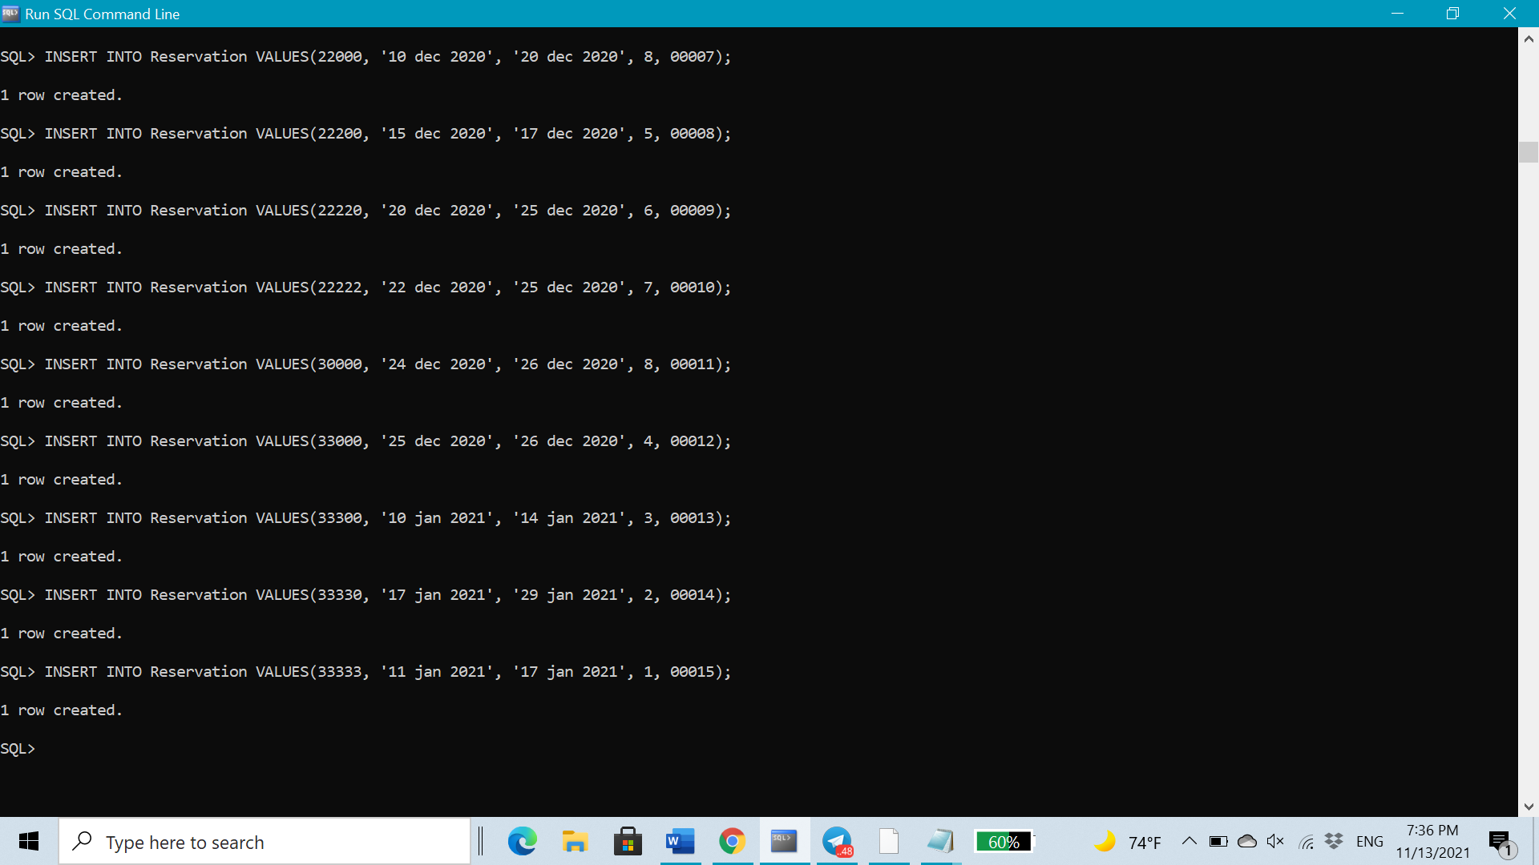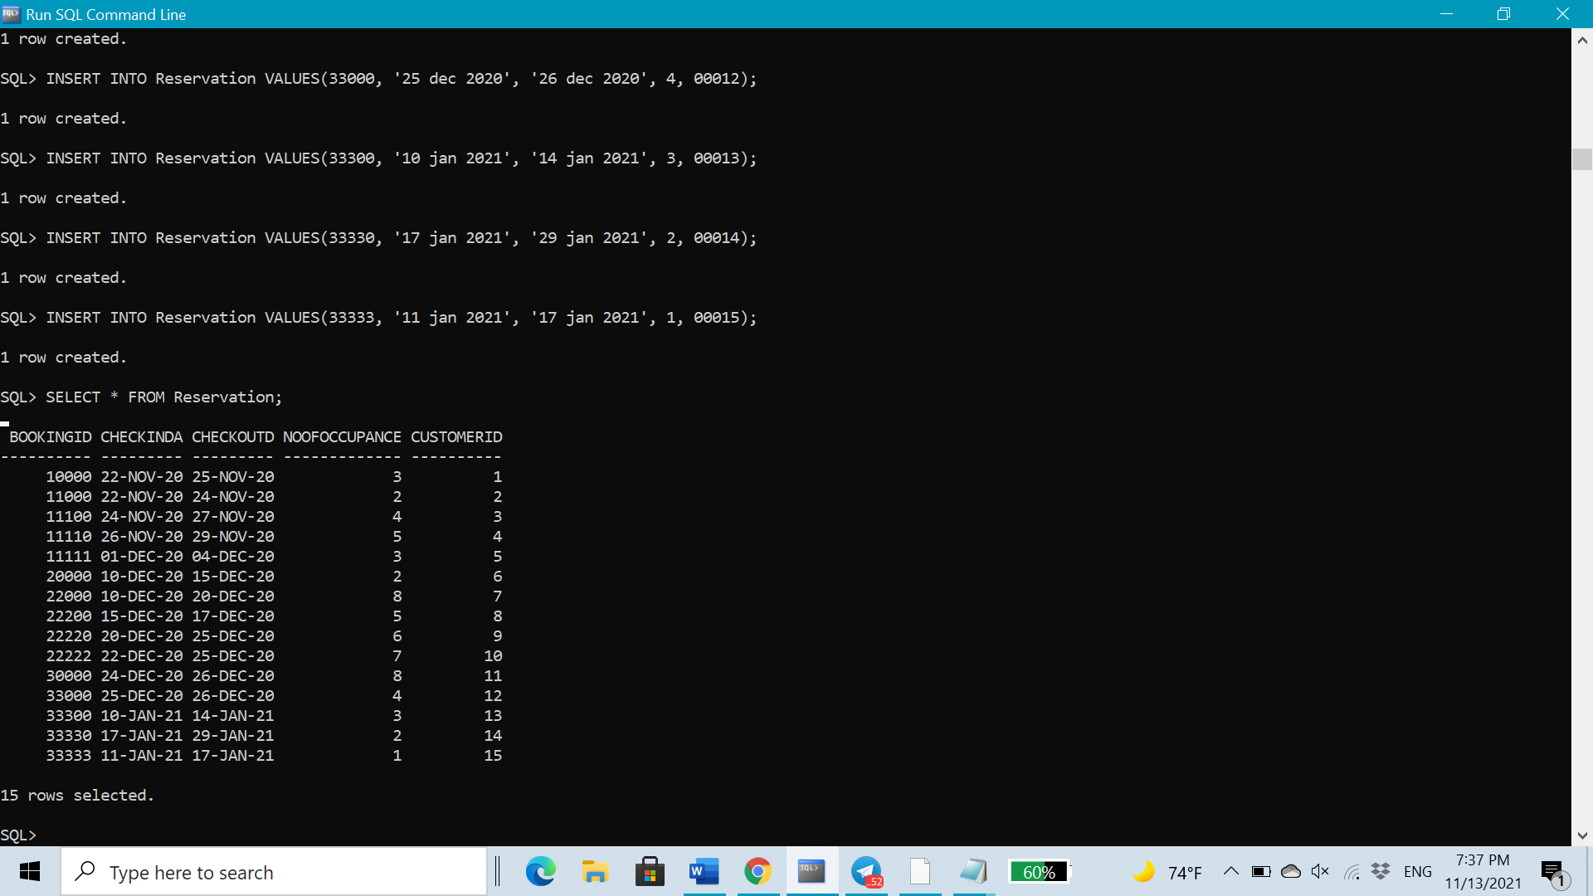

* ***Room Table***

DROP TABLE Room CASCADE CONSTRAINT;

CREATE TABLE **Room** (

roomNo NUMBER(3),

bookingID NUMBER(5),

hotelID VARCHAR2 (5),

customerID NUMBER,

roomType VARCHAR2(8), --possible values: standard, triple, suite

roomPrice NUMBER(4),

occupancy NUMBER(2),

status VARCHAR2(9), --possible values: available, occupied

CONSTRAINT PK_Room PRIMARY KEY(roomNo,hotelID),

CONSTRAINT customerID_Room FOREIGN KEY (customerID) REFERENCES Customer(customerID),

CONSTRAINT bookingID_Room FOREIGN KEY (bookingID) REFERENCES Reservation(bookingID),

CONSTRAINT hotelID_Room FOREIGN KEY (hotelID) REFERENCES Hotel(hotelID));

--INSERT room FOR hotel 1

INSERT INTO Room VALUES (101, 33330, 'ht01', 00014, 'standard', 450, 2, 'occupied');

INSERT INTO Room VALUES (102, 10000, 'ht01', 00001, 'triple', 700, 3, 'occupied');

INSERT INTO Room VALUES (103, 11110, 'ht01', 00004, 'suite', 1100, 5, 'occupied');

INSERT INTO Room VALUES (104, NULL, 'ht01', NULL, 'standard', 450, 2, 'available');

INSERT INTO Room VALUES (105, 33300, 'ht01', 00013, 'triple', 700, 3, 'occupied');

INSERT INTO Room VALUES (106, 22000, 'ht01', 00007, 'suite', 1100, 5, 'occupied');

INSERT INTO Room VALUES (107, NULL, 'ht01', NULL, 'standard', 450, 2, 'available');

INSERT INTO Room VALUES (108, NULL, 'ht01', NULL, 'triple', 700, 3, 'available');

INSERT INTO Room VALUES (109, 22000, 'ht01', 00007, 'suite', 1100, 5, 'occupied');

INSERT INTO Room VALUES (110, NULL, 'ht01', NULL, 'standard', 450, 2, 'available');

--INSERT room FOR hotel 2

INSERT INTO Room VALUES (201, 11000, 'ht02', 00002, 'standard', 450, 2, 'occupied');

INSERT INTO Room VALUES (202, 11111, 'ht02', 00005, 'triple', 700, 3, 'occupied');

INSERT INTO Room VALUES (203, 22200, 'ht02', 00008, 'suite', 1100, 5, 'occupied');

INSERT INTO Room VALUES (204, NULL, 'ht02', NULL, 'standard', 450, 2, 'available');

INSERT INTO Room VALUES (205, 22220, 'ht02', 00009, 'triple', 700, 3, 'occupied');

INSERT INTO Room VALUES (206, 33000, 'ht02', 00012, 'suite', 1100, 5, 'occupied');

INSERT INTO Room VALUES (207, NULL, 'ht02', NULL, 'standard', 450, 2, 'available');

INSERT INTO Room VALUES (208, 22220, 'ht02', 00009, 'triple', 700, 3, 'occupied');

INSERT INTO Room VALUES (209, NULL, 'ht02', NULL, 'suite', 1100, 5, 'available');

INSERT INTO Room VALUES (210, 33333, 'ht02', 00015, 'standard', 450, 2, 'occupied');

--INSERT room FOR hotel 3

INSERT INTO Room VALUES (301, 20000, 'ht03', 00006, 'standard', 450, 2, 'occupied');

INSERT INTO Room VALUES (302, NULL, 'ht03', NULL, 'triple', 700, 3, 'available');

INSERT INTO Room VALUES (303, 11100, 'ht03', 00003, 'suite', 1100, 5, 'occupied');

INSERT INTO Room VALUES (304, NULL, 'ht03', NULL, 'standard', 450, 2, 'available');

INSERT INTO Room VALUES (305, NULL, 'ht03', NULL, 'triple', 700, 3, 'available');

INSERT INTO Room VALUES (306, 22222, 'ht03', 00010, 'suite', 1100, 5, 'occupied');

INSERT INTO Room VALUES (307, 22222, 'ht03', 00010, 'standard', 450, 2, 'occupied');

INSERT INTO Room VALUES (308, 30000, 'ht03', 00011, 'triple', 700, 3, 'occupied');

INSERT INTO Room VALUES (309, 30000, 'ht03', 00011, 'suite', 1100, 5, 'occupied');

INSERT INTO Room VALUES (310, NULL, 'ht03', NULL, 'standard', 450, 2, 'available');

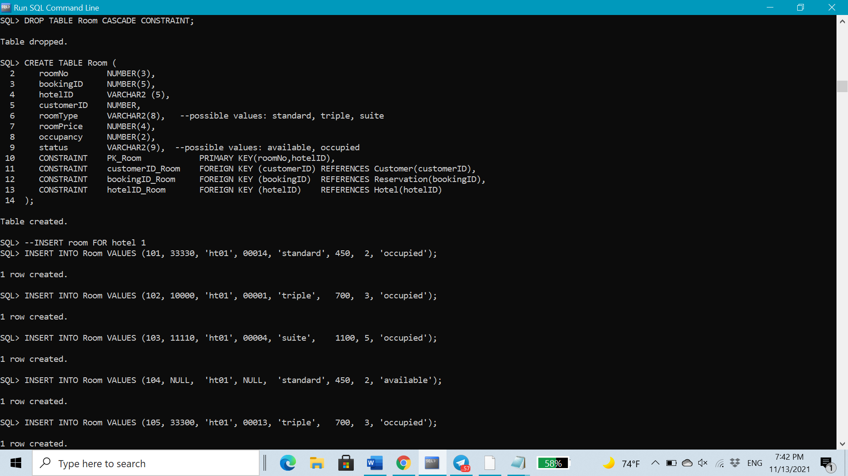

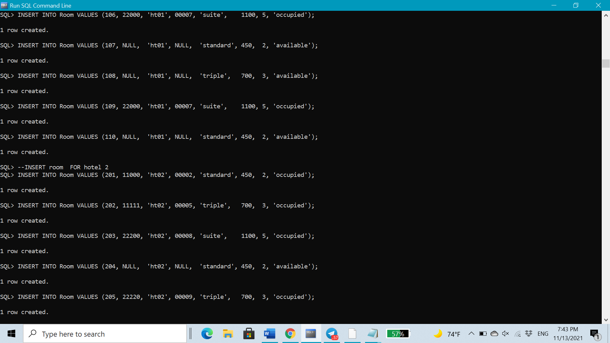

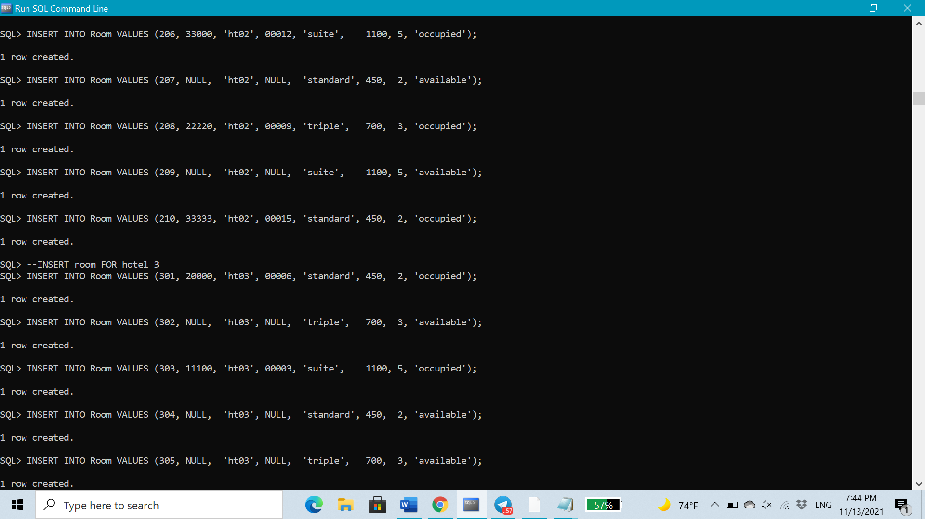

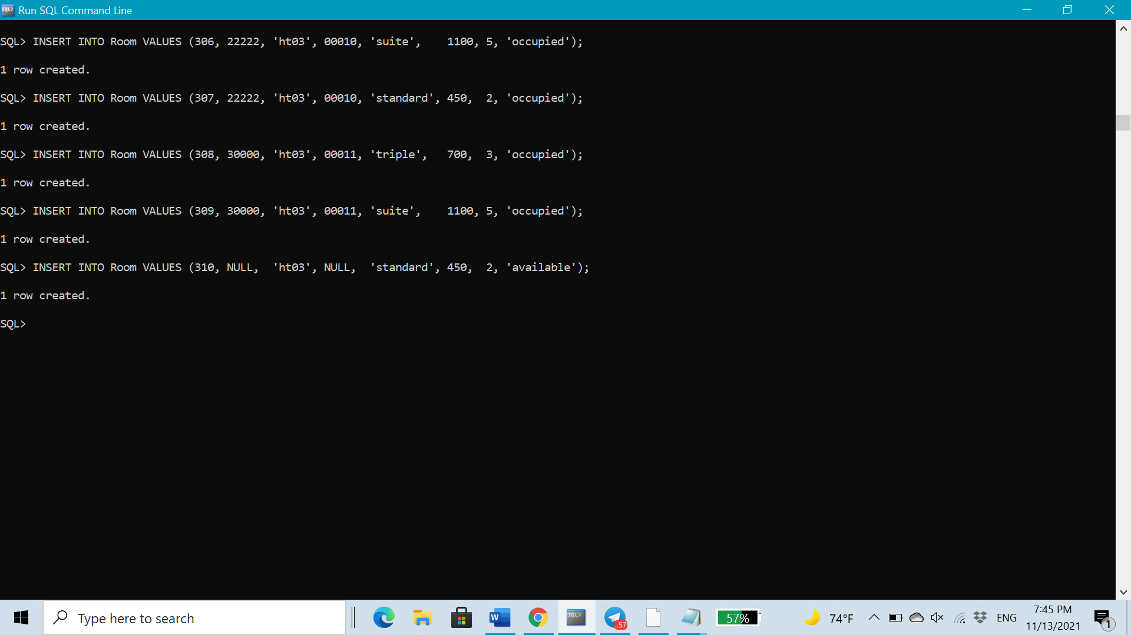

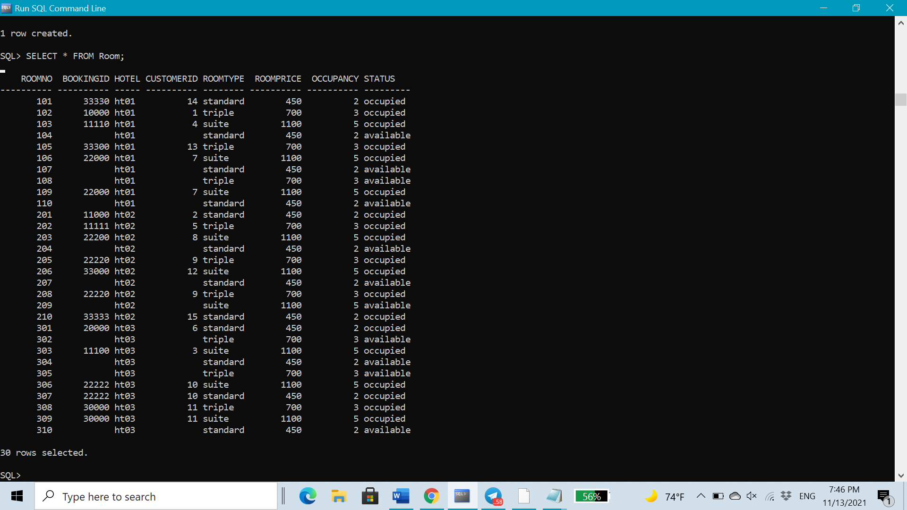

* ***Bill Table***

DROP TABLE Bill CASCADE CONSTRAINT;

CREATE TABLE **Bill** (

invoiceNo NUMBER (8),

roomCharge NUMBER(10),

roomService NUMBER(10),

numberOfDays NUMBER(3),

paymentDate DATE,

paymentMethod VARCHAR2(15), --Visa,Master card, Mada, Apple Pay

customerID NUMBER(5),

bookingID NUMBER(5),

CONSTRAINT invoiceNo_Bill PRIMARY KEY (invoiceNo),

CONSTRAINT customerID_Bill FOREIGN KEY (customerID) REFERENCES Customer(customerID),

CONSTRAINT bookingID_Bill FOREIGN KEY (bookingID) REFERENCES Reservation(bookingID)

);

INSERT INTO Bill VALUES(10000001, 4000,450, 3, '10 nov 2020', 'Mada', 00001,10000);

INSERT INTO Bill VALUES(10000002, 2500,250, 2, '20 oct 2020', 'MasterCard', 00002,11000);

INSERT INTO Bill VALUES(10000003, 3000,250, 3, '25 oct 2020', 'ApplePay', 00003,11100);

INSERT INTO Bill VALUES(10000004, 3000,500, 3, '17 nov 2020', 'Mada', 00004,11110);

INSERT INTO Bill VALUES(10000005, 3500,1000, 3, '29 nov 2020', 'ApplePay', 00005,11111);

INSERT INTO Bill VALUES(10000006, 6000,750, 5, '03 dec 2020', 'Visa', 00006,20000);

INSERT INTO Bill VALUES(10000007, 1075,1050, 9, '25 nov 2020', 'Mada', 00007,22000);

INSERT INTO Bill VALUES(10000008, 2500,1000, 2, '15 dec 2020', 'MasterCard', 00008,22200);

INSERT INTO Bill VALUES(10000009, 5500,500, 5, '01 dec 2020', 'Visa', 00009,22220);

INSERT INTO Bill VALUES(10000010, 3000,500, 3, '20 dec 2020', 'ApplePay', 00010,22222);

INSERT INTO Bill VALUES(10000011, 1500,150, 2, '07 dec 2020', 'MasterCard', 00011,30000);

INSERT INTO Bill VALUES(10000012, 7506,150, 1, '12 dec 2020', 'Mada', 00012,33000);

INSERT INTO Bill VALUES(10000013, 5000,500, 4, '01 jan 2021', 'Visa', 00013,33300);

INSERT INTO Bill VALUES(10000014, 1450,2500, 12, '16 jan 2021', 'MasterCard', 00014,33330);

INSERT INTO Bill VALUES(10000015, 8500,1500, 6, '05 jan 2021', 'ApplePay', 00015,33333);

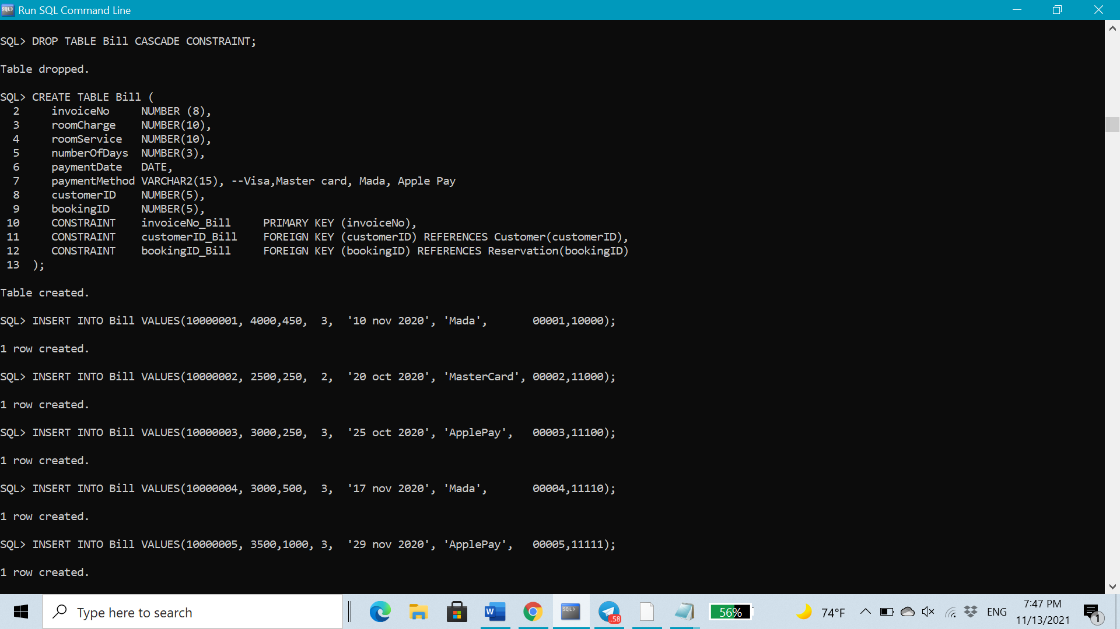

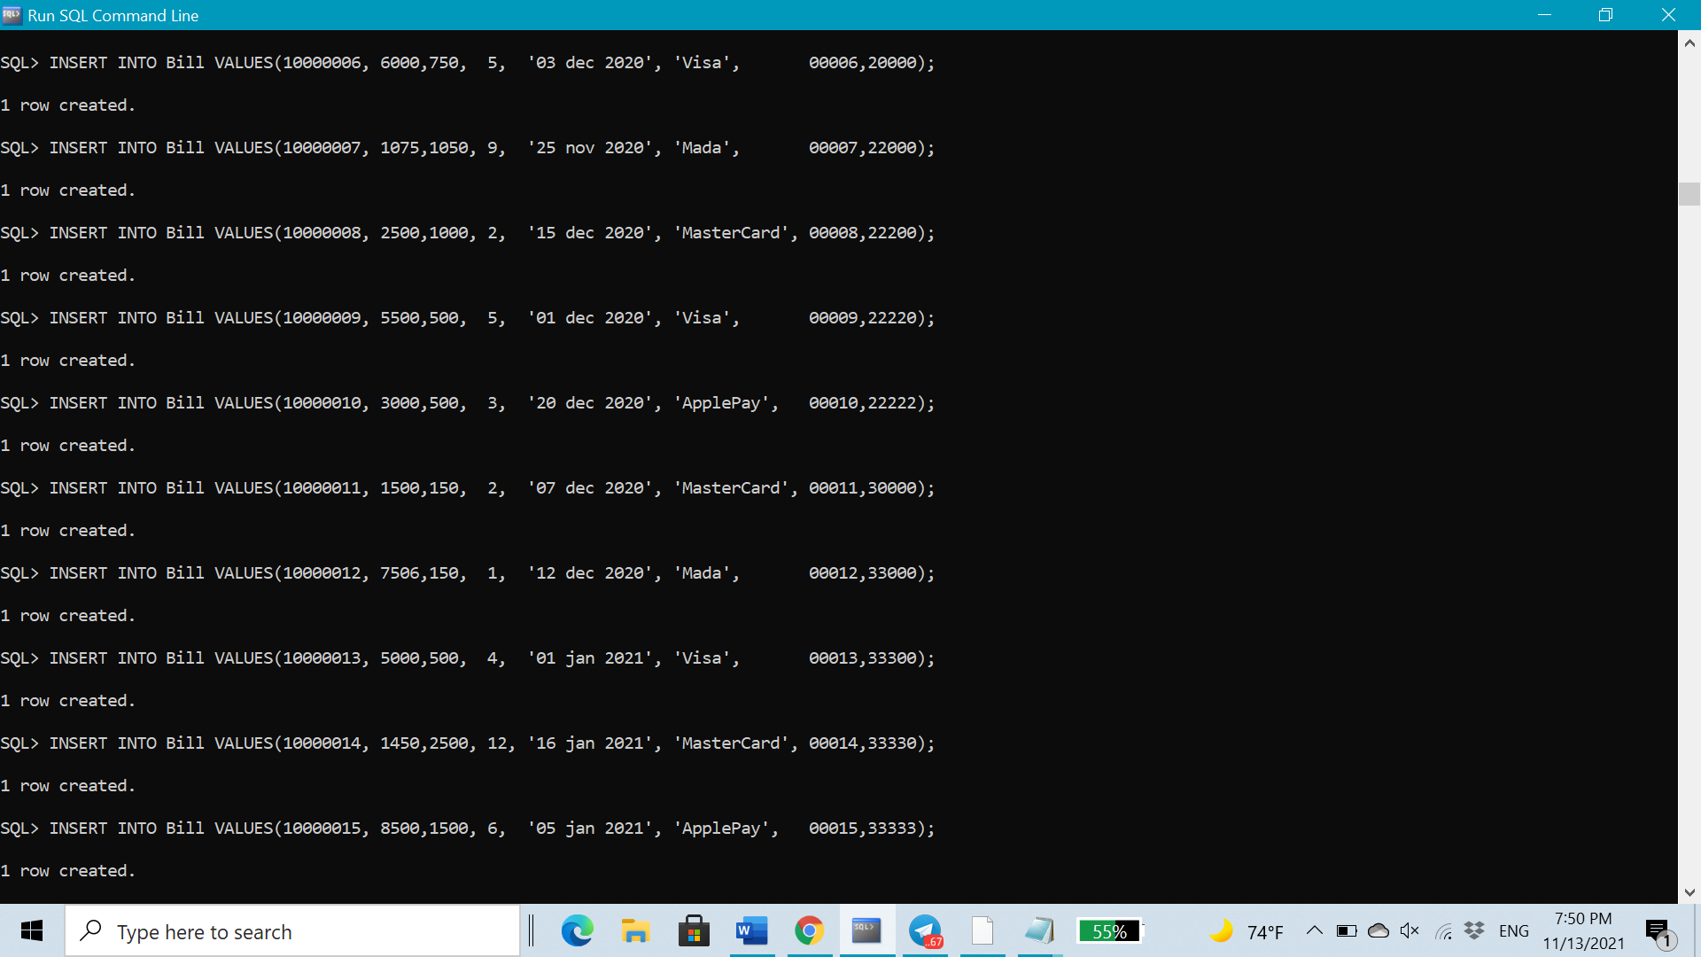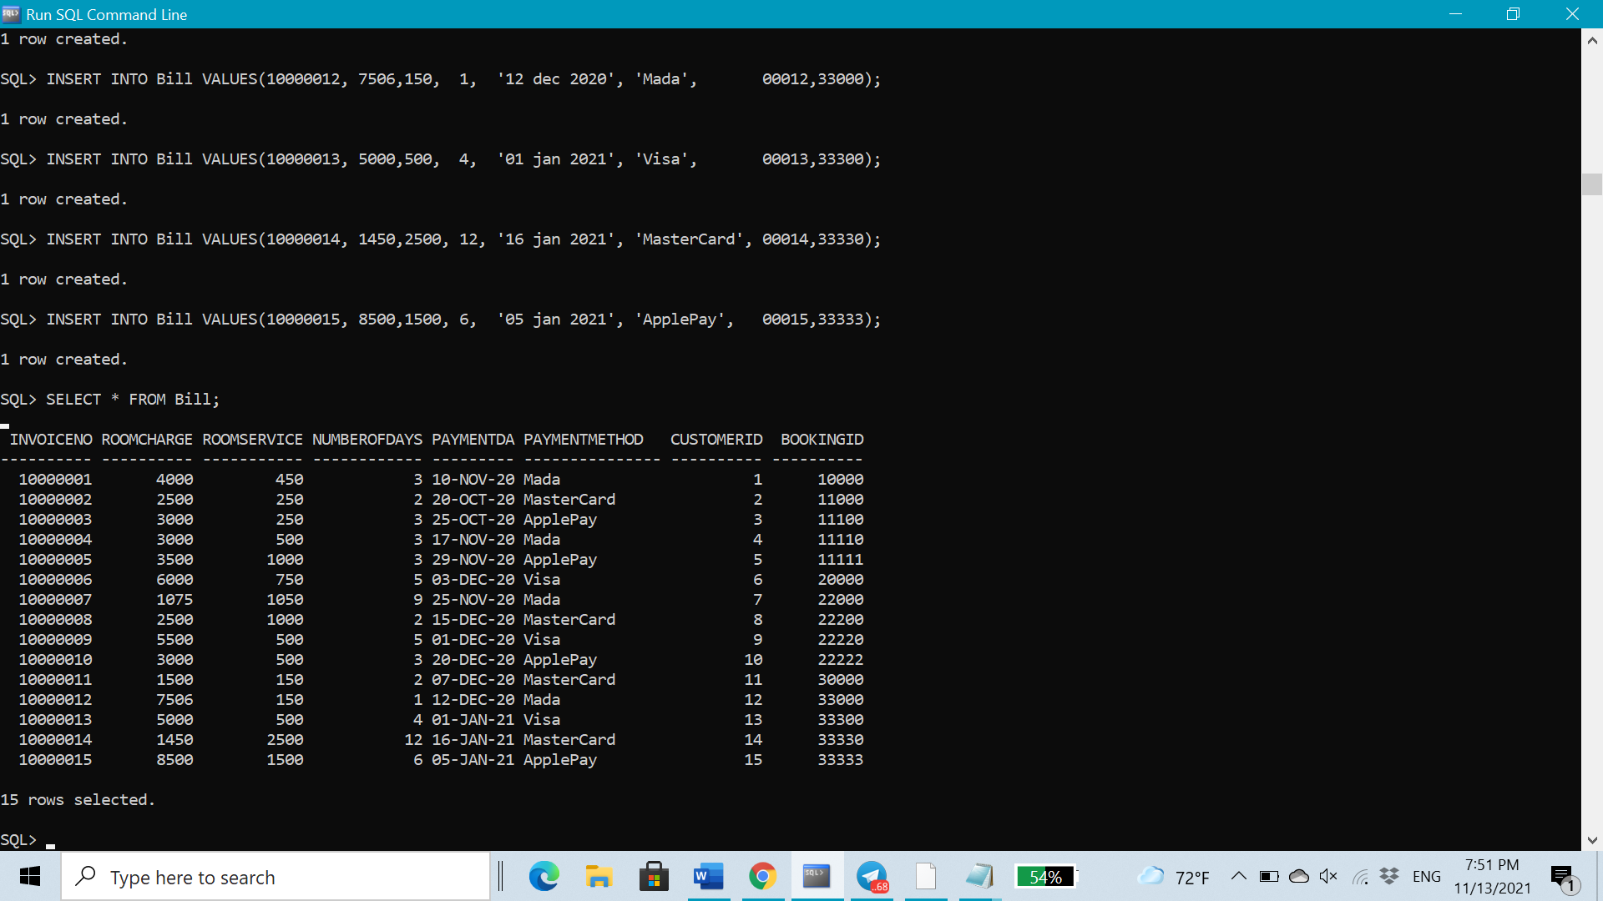

* ***Request Table***

DROP TABLE Request CASCADE CONSTRAINT;

CREATE TABLE **Request** (

reqDate DATE,

reqTime VARCHAR2(20),

customerID NUMBER(5),

hotelID VARCHAR2 (5),

roomNo NUMBER(3),

CONSTRAINT PK_Request PRIMARY KEY(customerID,roomNo),

CONSTRAINT customerID_Request FOREIGN KEY (customerID) REFERENCES Customer(customerID),

CONSTRAINT hotelID_roomNo_Request FOREIGN KEY (roomNo,hotelID) REFERENCES Room(roomNo,hotelID)

);

INSERT INTO Request VALUES ('01 nov 2021', '03:30', 00001, 'ht01',101);

INSERT INTO Request VALUES ('01 nov 2021', '01:00', 00002, 'ht01',104);

INSERT INTO Request VALUES ('02 nov 2021', '02:10', 00003, 'ht01',101);

INSERT INTO Request VALUES ('02 nov 2021', '02:00', 00004, 'ht01',103);

INSERT INTO Request VALUES ('03 nov 2021', '04:30', 00005, 'ht02',210);

INSERT INTO Request VALUES ('03 nov 2021', '04:00', 00006, 'ht02',205);

INSERT INTO Request VALUES ('04 nov 2021', '05:00', 00007, 'ht02',206);

INSERT INTO Request VALUES ('04 nov 2021', '08:40', 00008, 'ht03',310);

INSERT INTO Request VALUES ('04 nov 2021', '06:30', 00009, 'ht01',107);

INSERT INTO Request VALUES ('05 nov 2021', '03:30', 00010, 'ht03',308);

INSERT INTO Request VALUES ('06 nov 2021', '03:00', 00011, 'ht01',110);

INSERT INTO Request VALUES ('07 nov 2021', '01:50', 00012, 'ht02',204);

INSERT INTO Request VALUES ('07 nov 2021', '06:40', 00013, 'ht01',109);

INSERT INTO Request VALUES ('08 nov 2021', '06:30', 00014, 'ht01',104);

INSERT INTO Request VALUES ('09 nov 2021', '02:10', 00015, 'ht03',301);

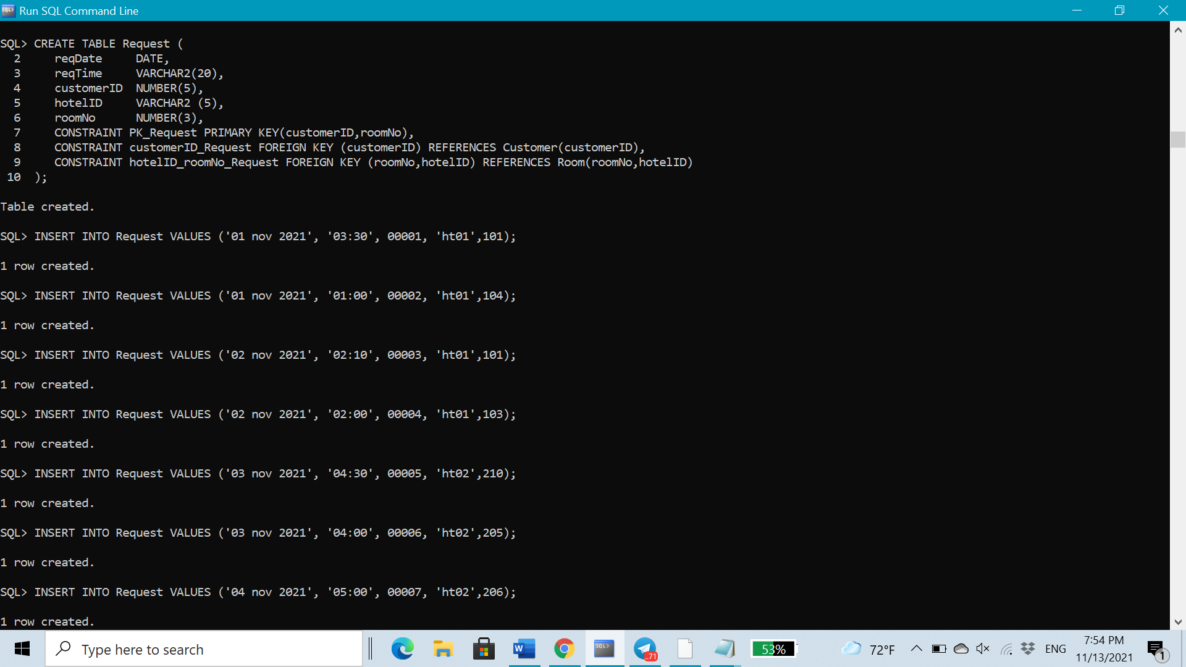

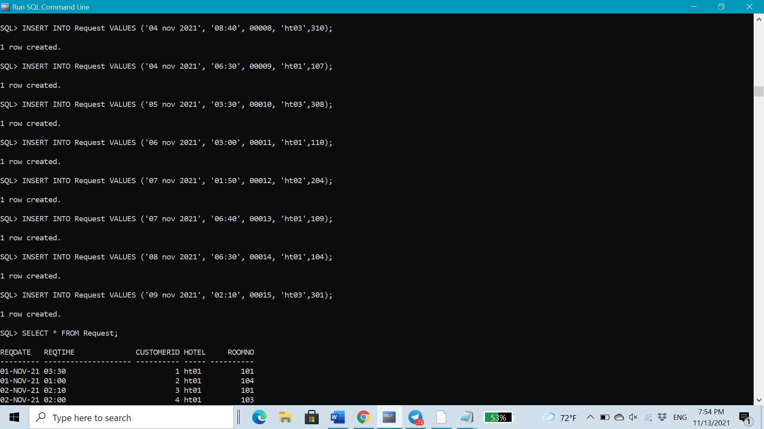

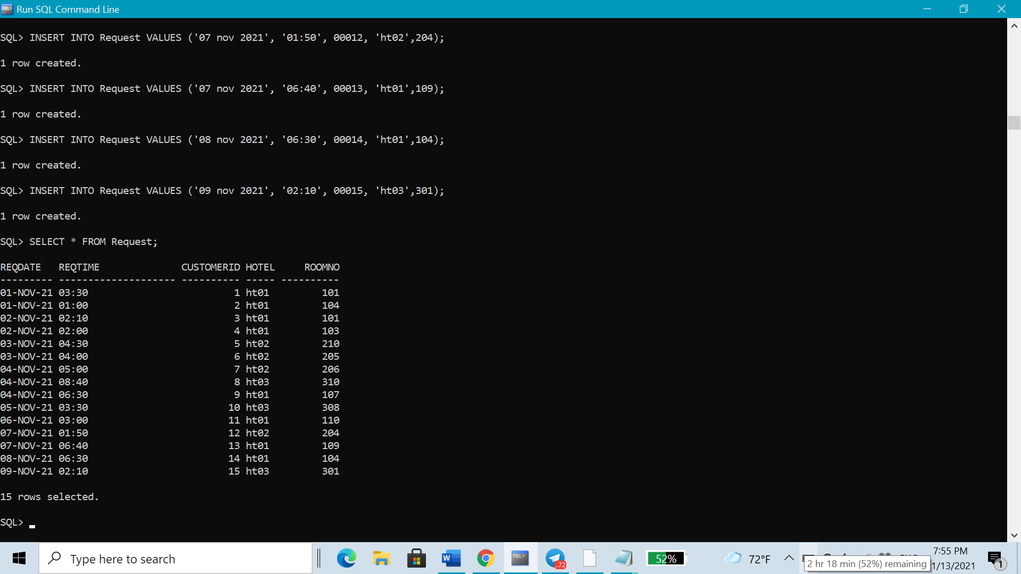

* ***Reserve Table***

DROP TABLE Reserve CASCADE CONSTRAINT;

CREATE TABLE **Reserve** (

bookingID NUMBER(5),

roomNo NUMBER(3),

hotelID VARCHAR2 (5),

CONSTRAINT PK_Reserve PRIMARY KEY(bookingID,roomNo),

CONSTRAINT bookingID_Reserve FOREIGN KEY (bookingID) REFERENCES Reservation(bookingID),

CONSTRAINT hotelID_roomNo_Reserve FOREIGN KEY (roomNo,hotelID) REFERENCES Room(roomNo,hotelID));

INSERT INTO Reserve VALUES (10000, 108,'ht01');

INSERT INTO Reserve VALUES (11000, 104,'ht01');

INSERT INTO Reserve VALUES (11100, 101,'ht01');

INSERT INTO Reserve VALUES (11110, 203,'ht02');

INSERT INTO Reserve VALUES (11111, 201,'ht02');

INSERT INTO Reserve VALUES (20000, 305,'ht03');

INSERT INTO Reserve VALUES (22000, 306,'ht03');

INSERT INTO Reserve VALUES (22200, 110,'ht01');

INSERT INTO Reserve VALUES (22220, 107,'ht01');

INSERT INTO Reserve VALUES (22222, 208,'ht02');

INSERT INTO Reserve VALUES (30000, 210,'ht02');

INSERT INTO Reserve VALUES (33000, 104,'ht01');

INSERT INTO Reserve VALUES (33300, 309,'ht03');

INSERT INTO Reserve VALUES (33330, 304,'ht03');

INSERT INTO Reserve VALUES (33333, 301,'ht03');

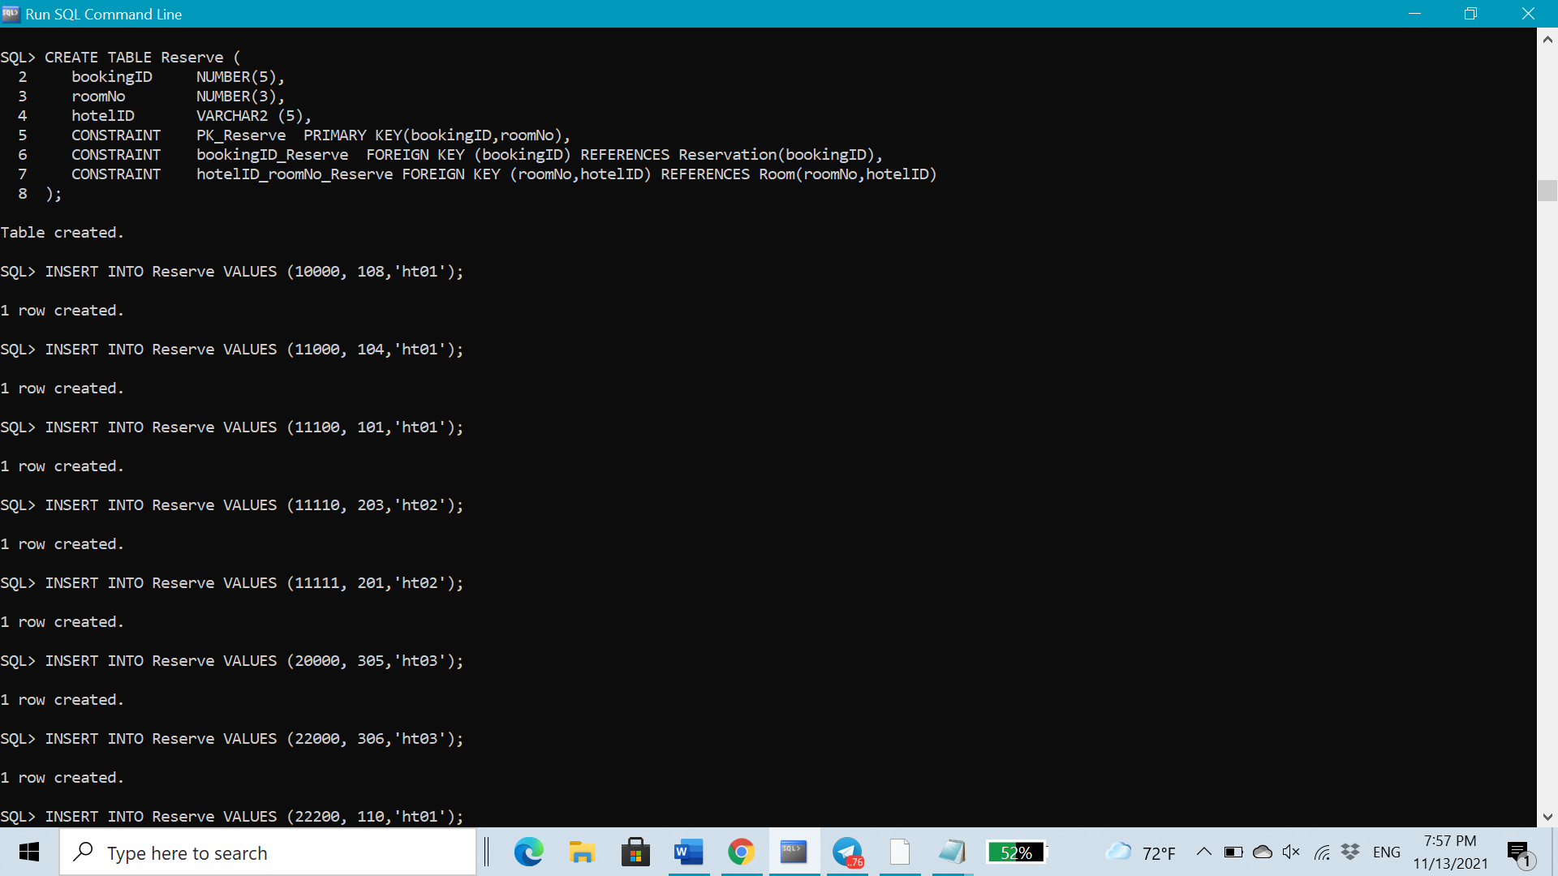

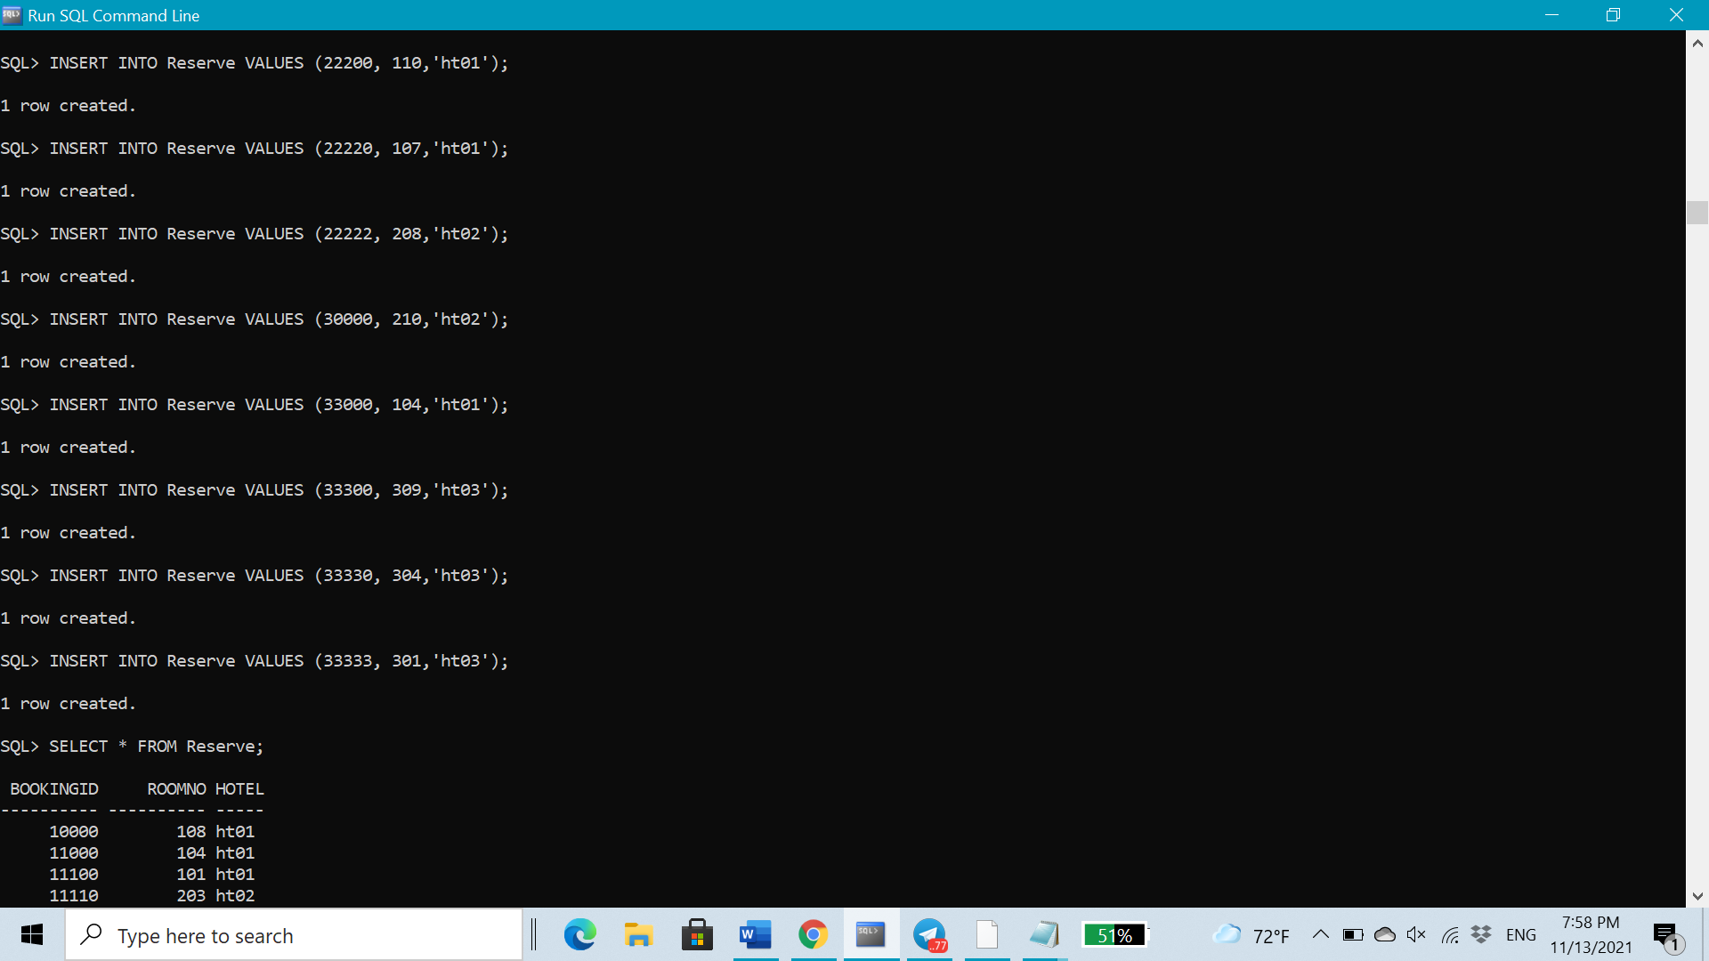

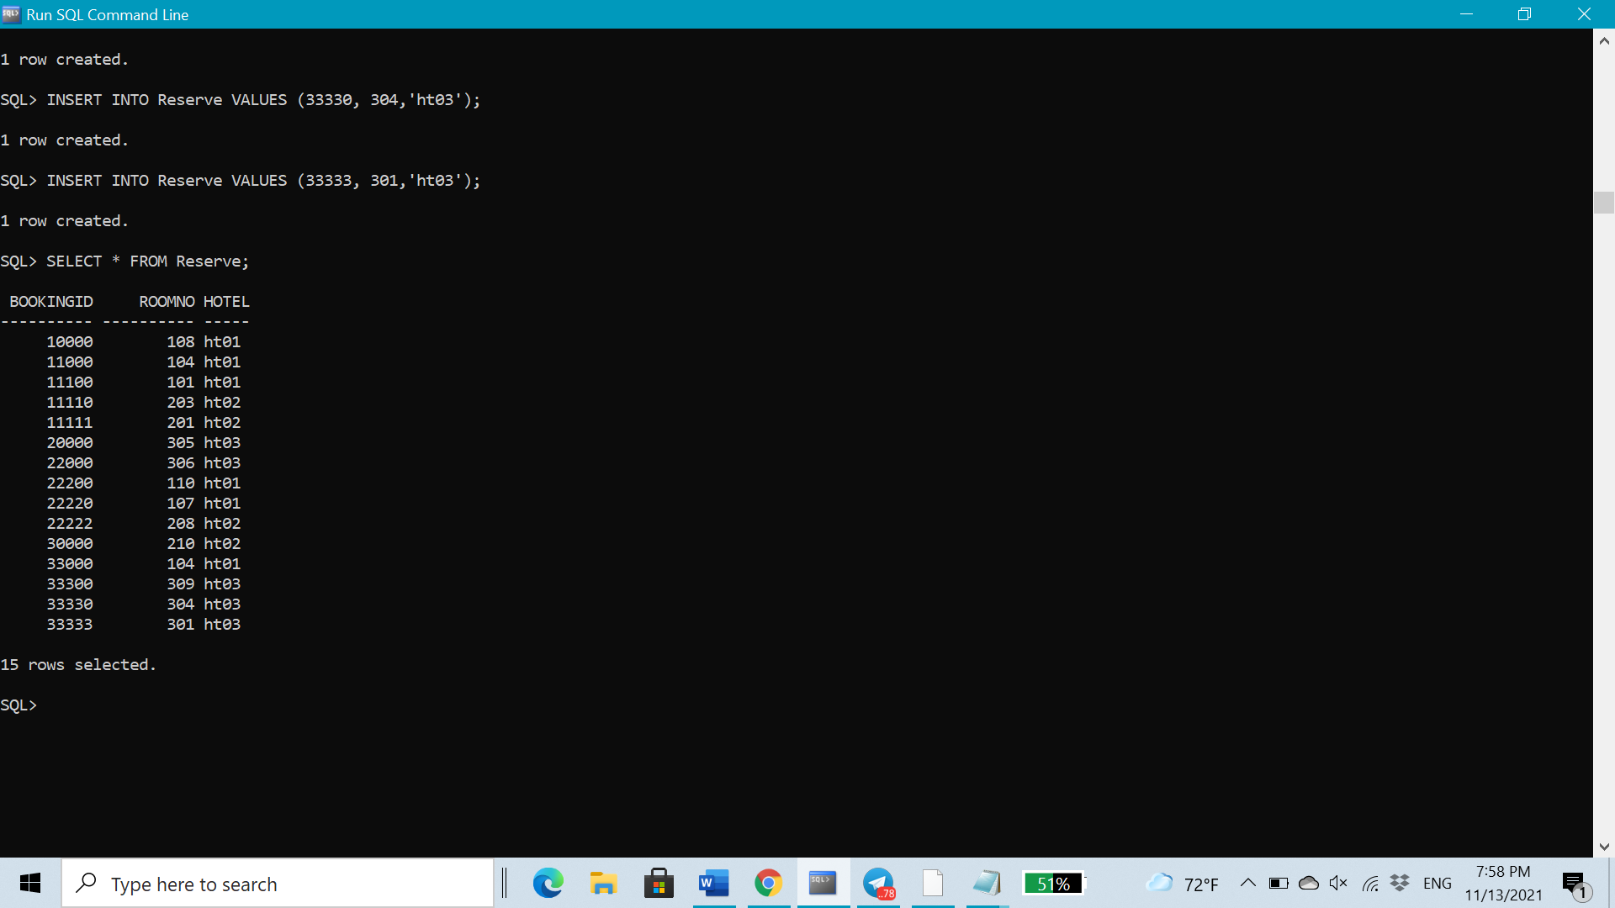

***Creation of Functions:***

***Function1:***

SET SERVEROUTPUT ON;

CREATE OR REPLACE FUNCTION **total_Employee**

RETURN number IS

total number := 0;

BEGIN

SELECT count(*) into total

FROM Employee;

RETURN total;

END;

**/**

DECLARE

c number;

BEGIN

c := total_Employee();

dbms_output.put_line('Total Number Of Employee Is: ' || c); --16

END;

**/**

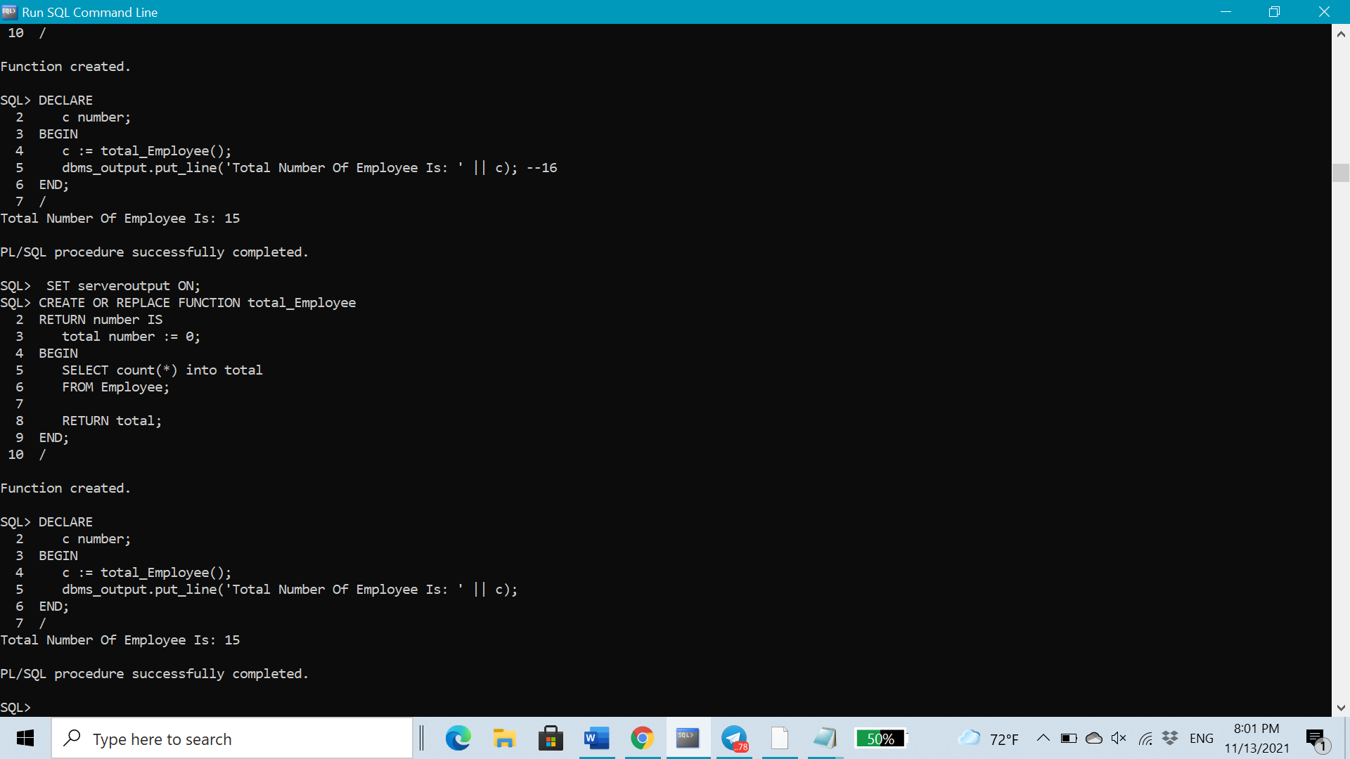

***Function2:***

CREATE OR REPLACE FUNCTION **occupied_room**

RETURN number IS

unavaRoom number := 0;

BEGIN

SELECT count(bookingID) into unavaRoom

FROM Room ;

RETURN unavaRoom;

END;

/

DECLARE

o number;

BEGIN

o := occupied_room();

dbms_output.put_line('The Number Of Occupied Room Is: ' || o);

END;

/

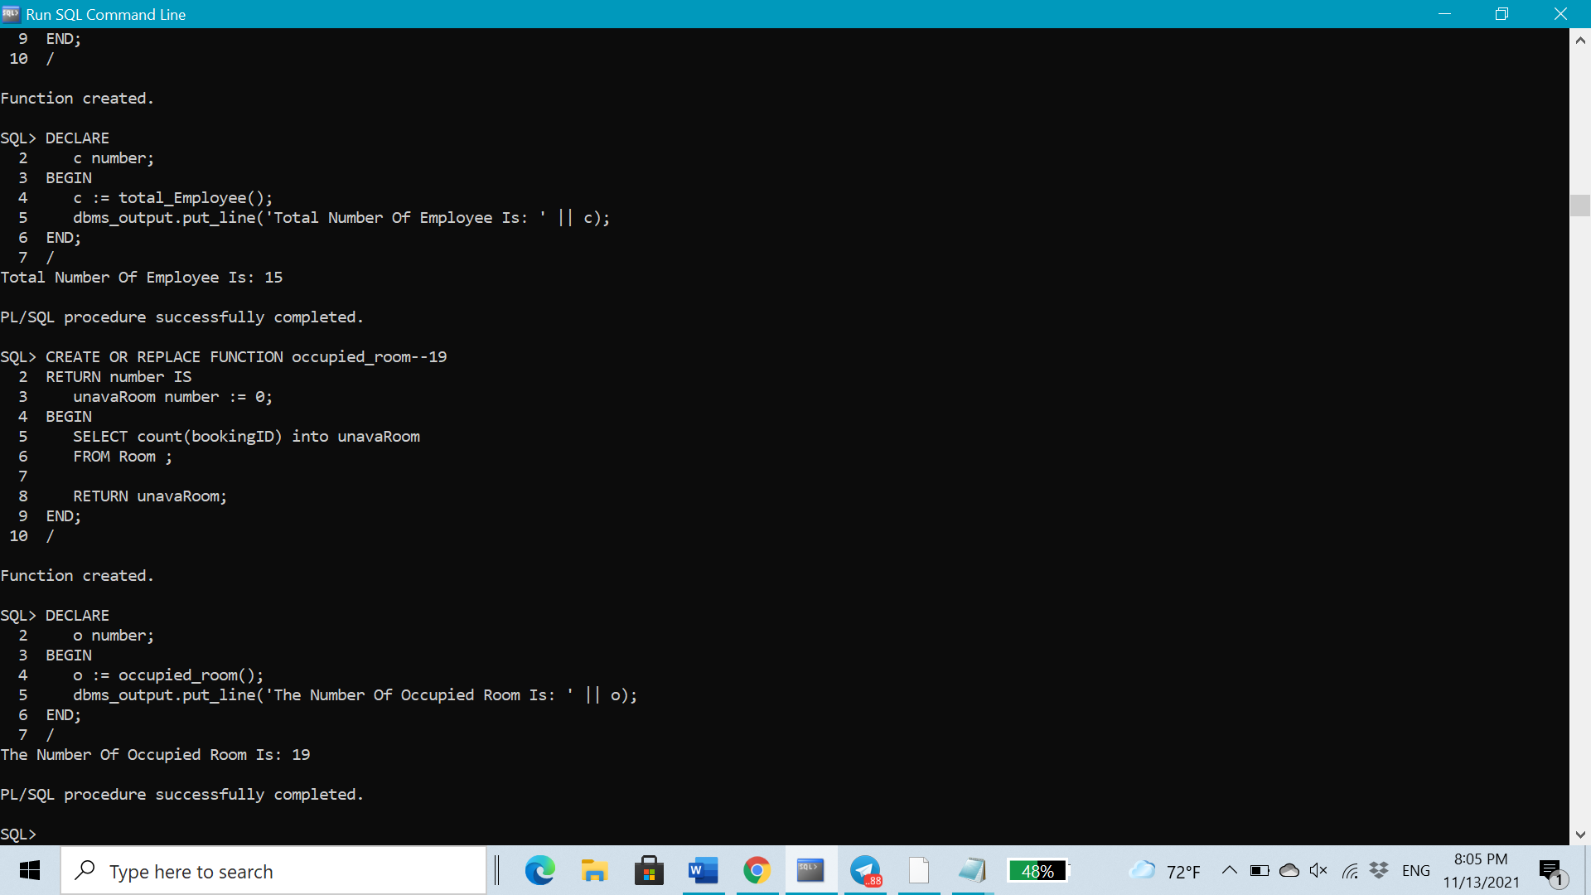

***Function3:***

CREATE OR REPLACE FUNCTION **all_room**

RETURN number IS

numRoom number := 0;

BEGIN

SELECT count(roomNo) into numRoom

FROM Room ;

RETURN numRoom;

END;

**/**

DECLARE

availableRoom number;

allRooms number;

occupiedRoom number;

BEGIN

occupiedRoom:= occupied_room();

allRooms:= all_room();

availableRoom:=allRooms-occupiedRoom;

dbms_output.put_line('Total number of rooms in all hotels is: ' ||allRooms);--30

dbms_output.put_line('occupied room is: ' ||occupiedRoom); --19

dbms_output.put_line('available room is: ' ||availableRoom);--11

END;

**/**

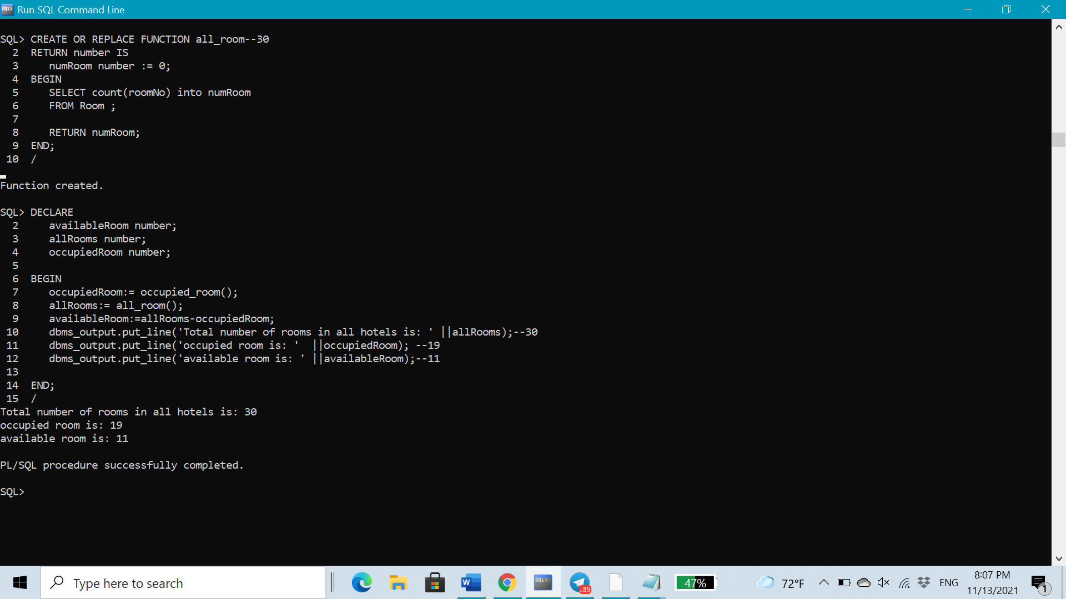

***Creation of Triggers:***

CREATE OR REPLACE TRIGGER **CheckAge**

BEFORE INSERT OR UPDATE ON Customer

FOR EACH ROW

BEGIN

IF:NEW.Age < 18 THEN

raise_application_error(-20001, 'Age must be 18 and older');

END IF;

END;

/

--INSERT NEW customer

INSERT INTO Customer VALUES (00016,18,'male',966554365189,'fo90na@gmail.com','xsw36hucde','Saudi Arabia', 'Abha', 00333, 'Hajar', 'Aleid');

INSERT INTO Customer VALUES (00017,16,'male',966554300189,'heloojo@gmail.com','xspl1hucde','Saudi Arabia','Dammam', 00033 , 'Mohammed','Algahtani');

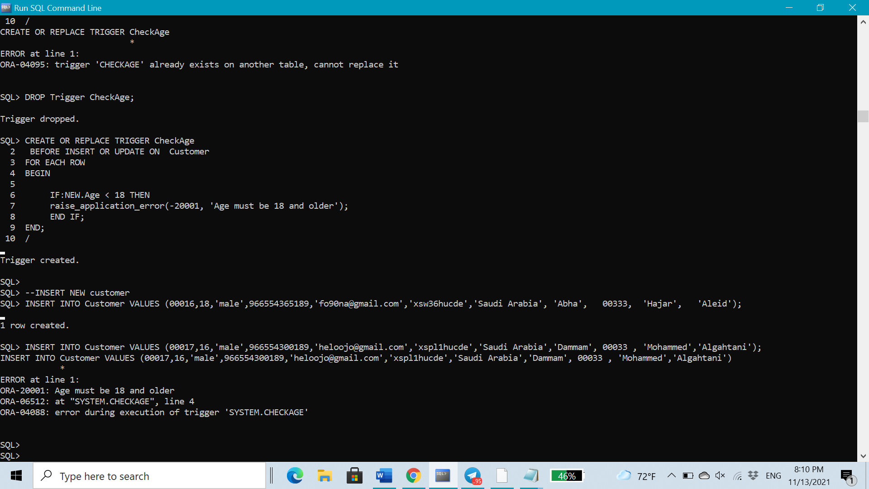

CREATE OR REPLACE TRIGGER **salary_changes**

BEFORE INSERT OR UPDATE ON Employee

FOR EACH ROW

DECLARE

sal_diff NUMBER;

precentage FLOAT(6);

t FLOAT(6);

BEGIN

sal_diff:= :NEW.salary - :OLD.salary;

precentage:=sal_diff/:OLD.salary ;

t := precentage*100;

dbms_output.put_line('OLD salary:'|| :OLD.salary);

dbms_output.put_line('NEW salary:'|| :NEW.salary);

dbms_output.put_line('The amount of the salary increase in percentage is : '||t||' % ');

END;

/

--INSERT NEW manager in hotel 3

INSERT INTO Employee VALUES(11016,'manager','Sawsan','Saad',7000.00,'966588834266','26','Sawsan990@hotmail.com','iyhtozrq43','ht03');

--UPDATE salary FOR staff ahmad

UPDATE Employee SET salary=salary+3000 WHERE employeeID=11001;

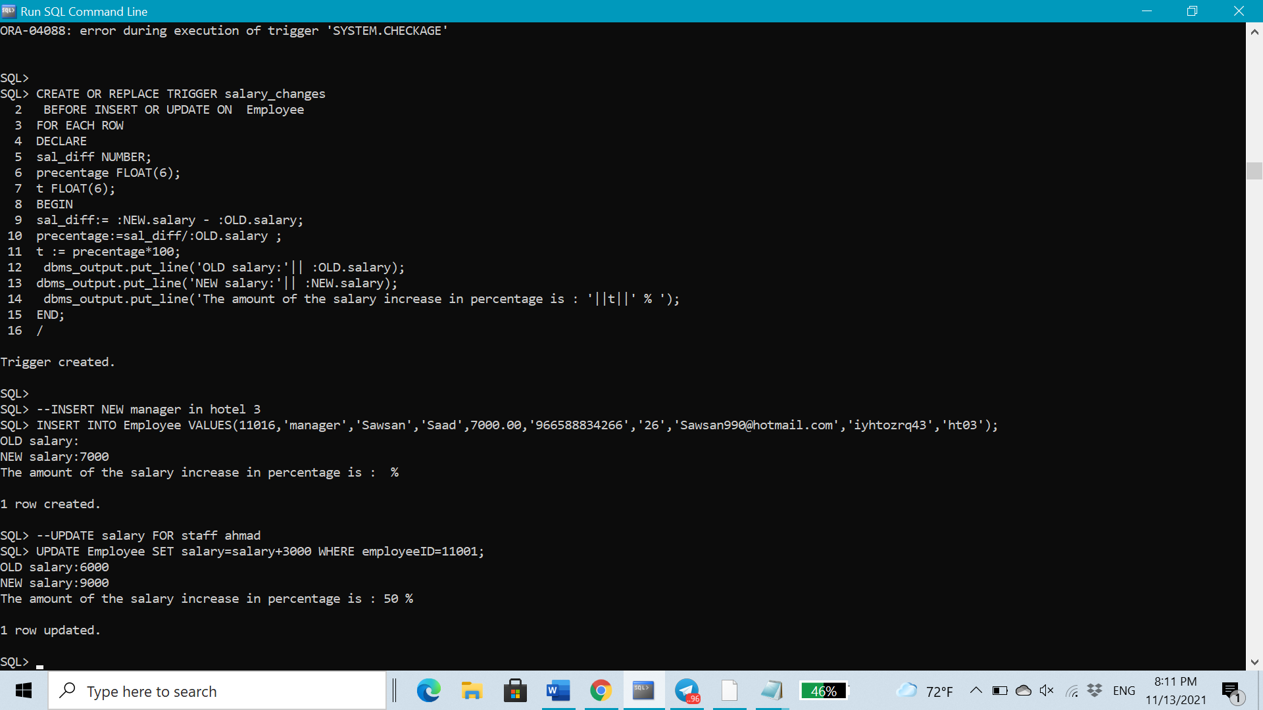

***User interface including forms and reports:***

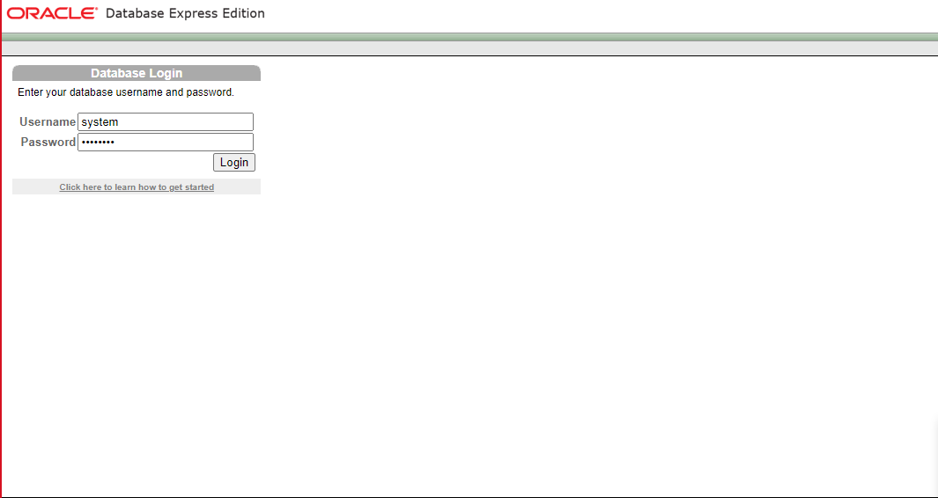

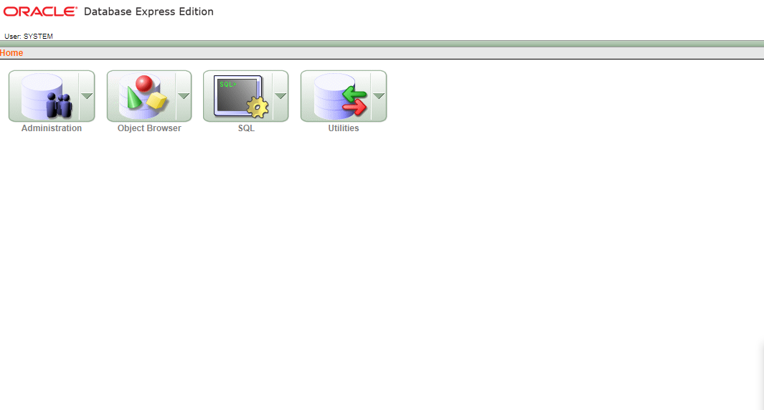

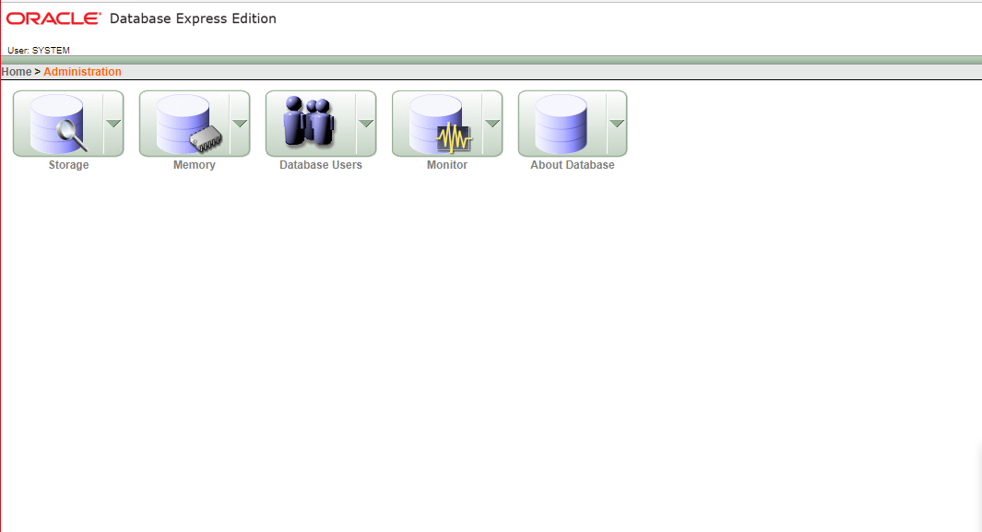

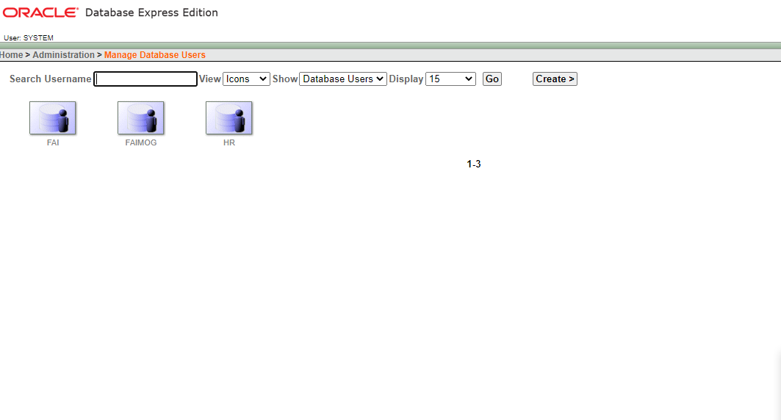

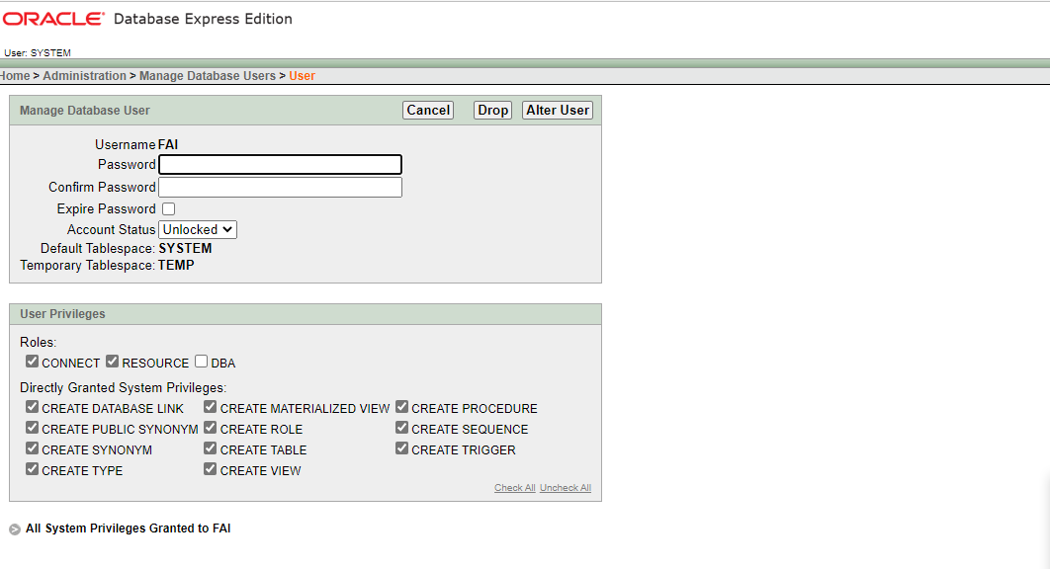

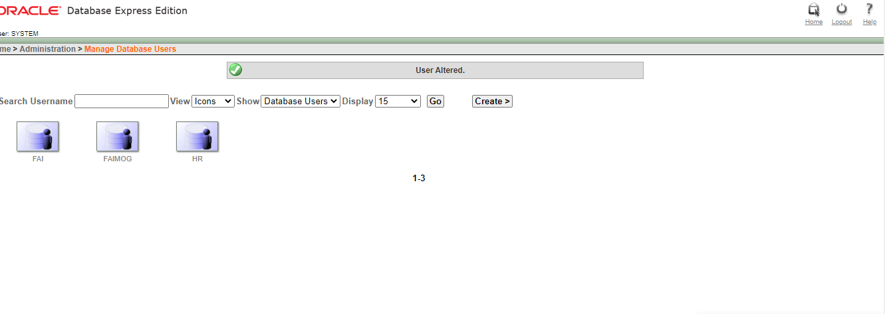

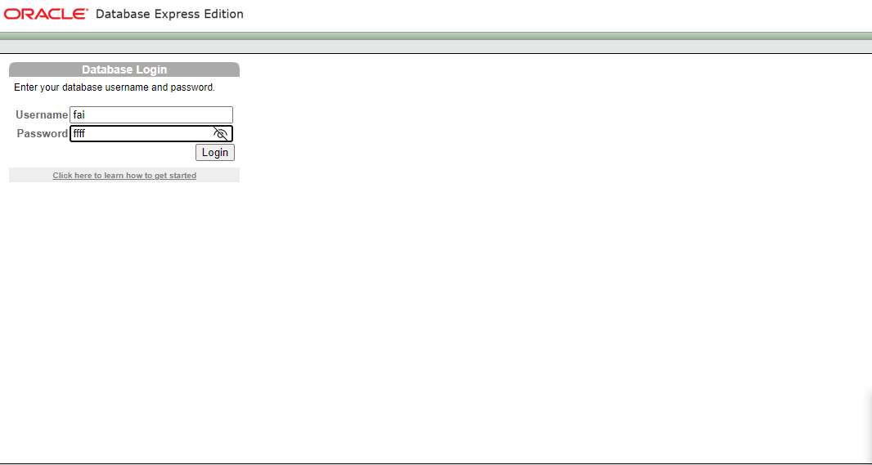

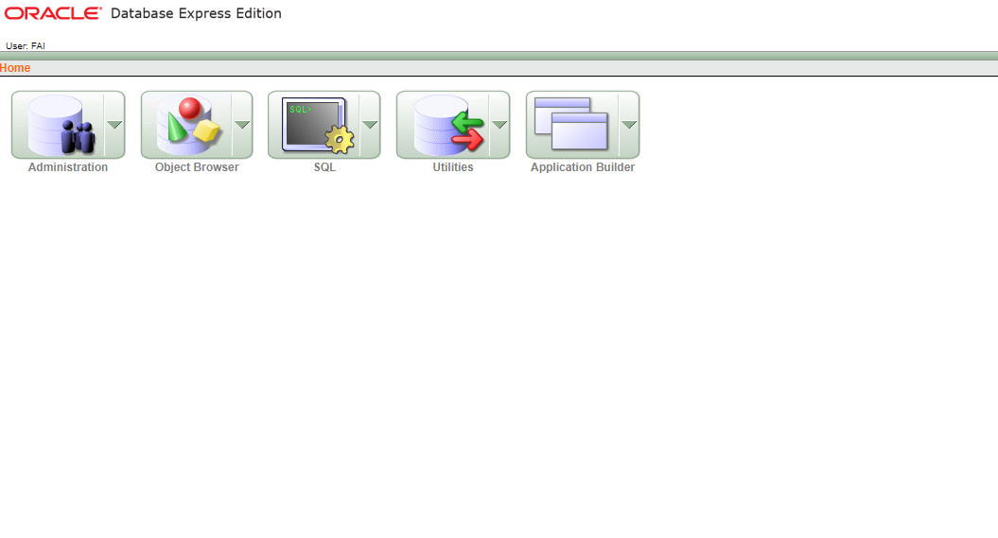

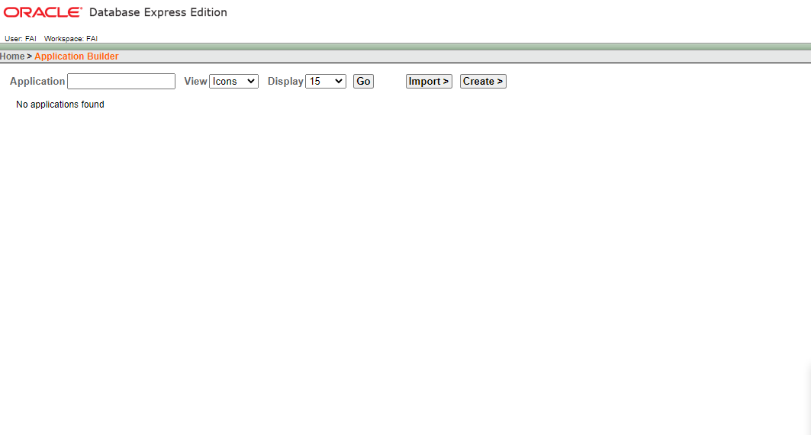

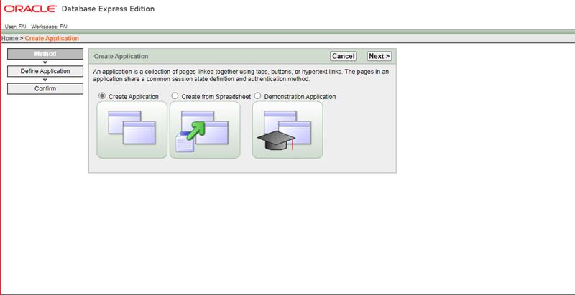

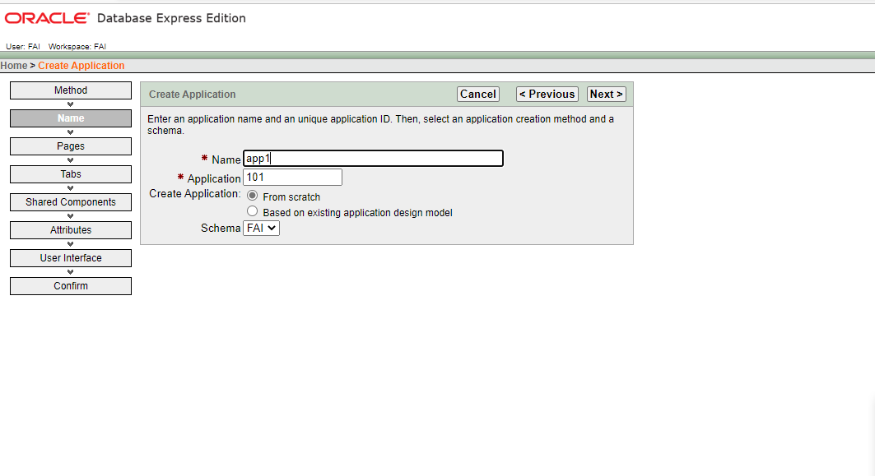

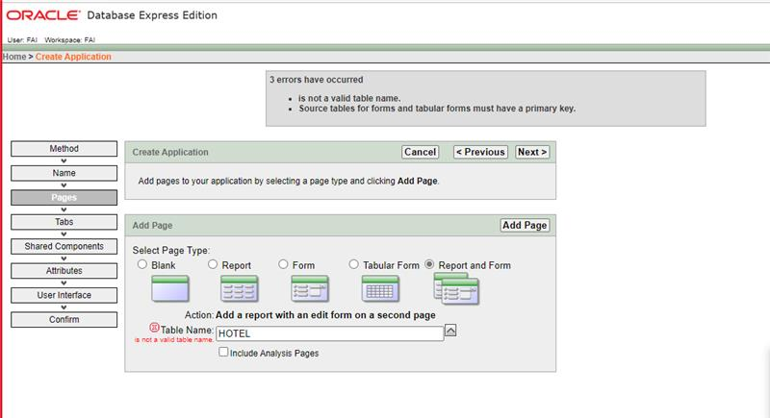

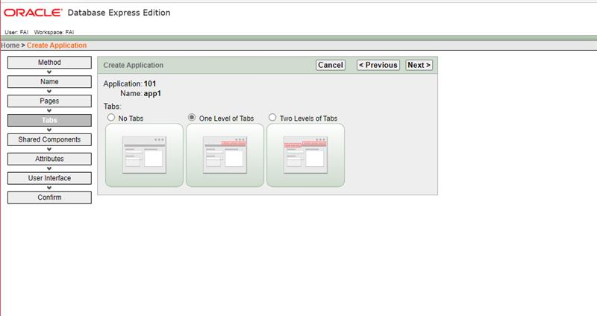

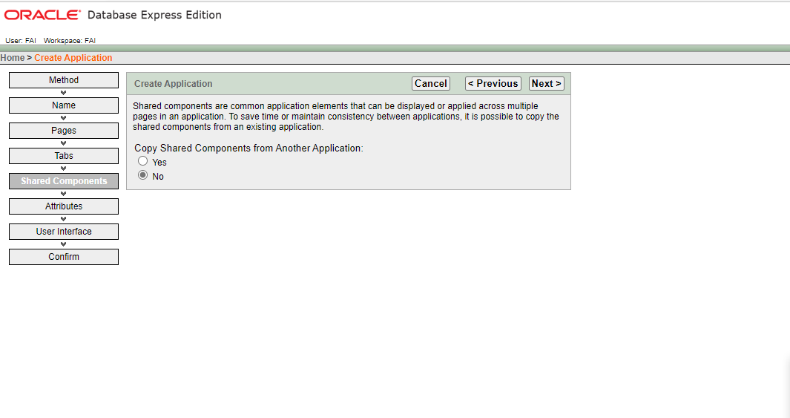

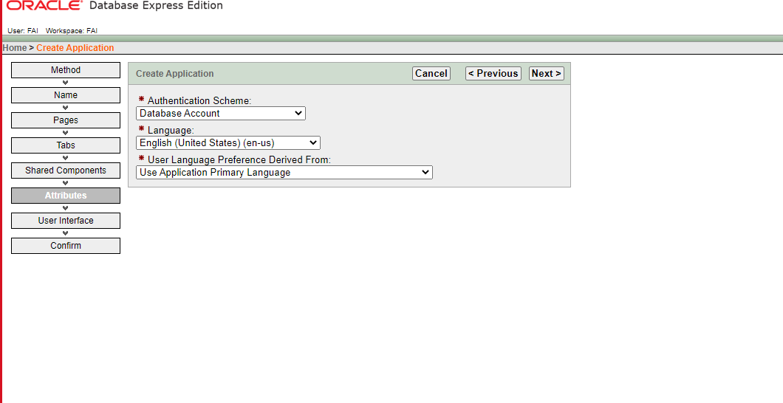

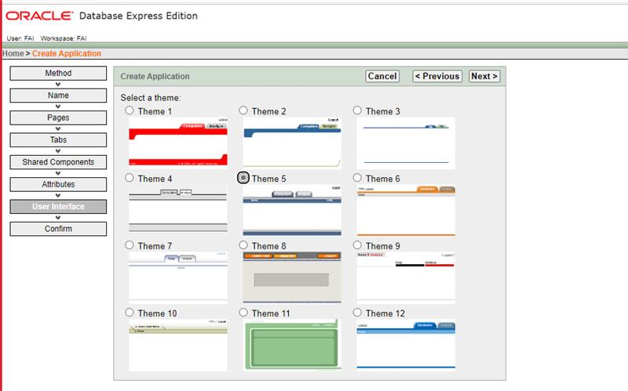

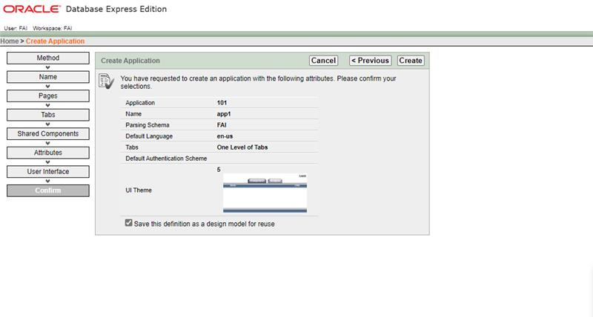

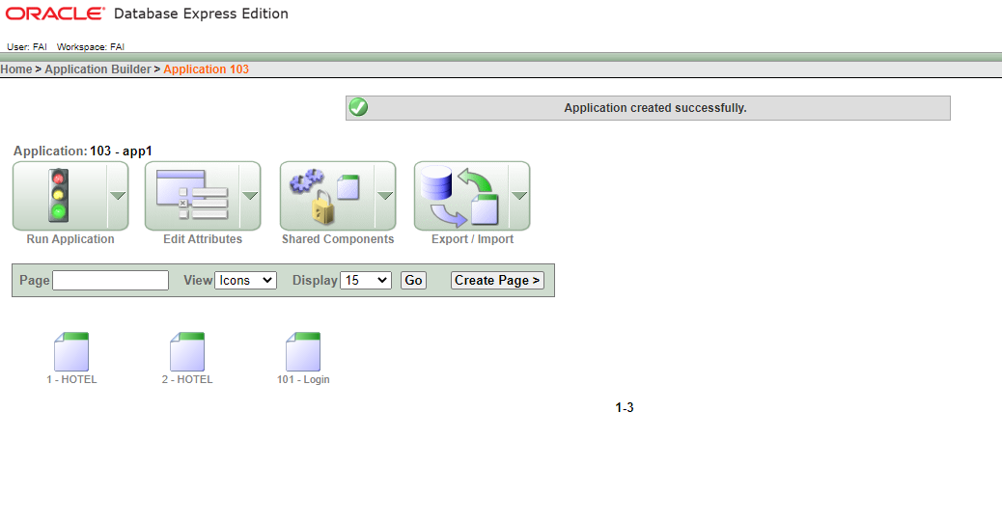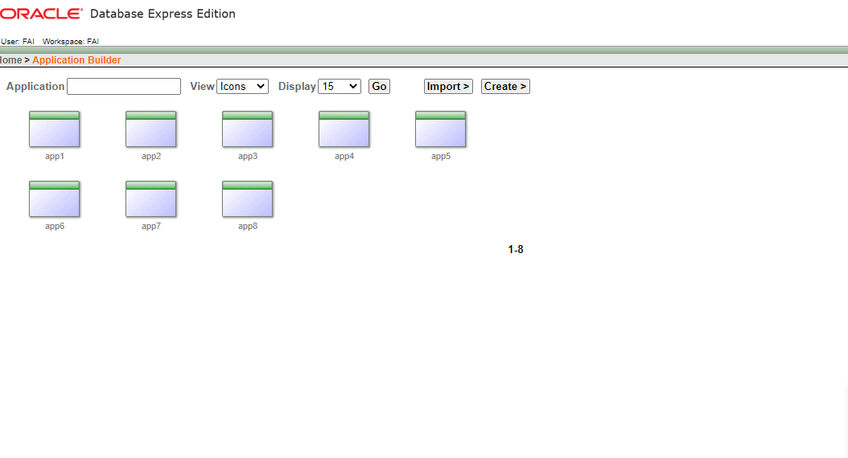

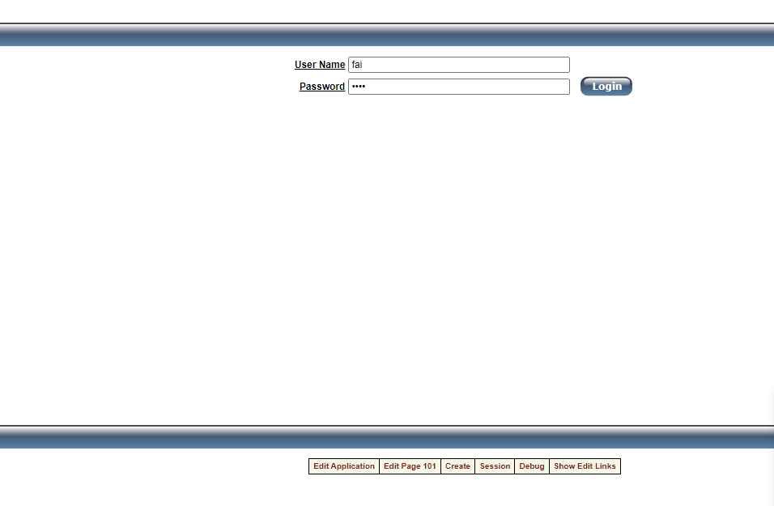

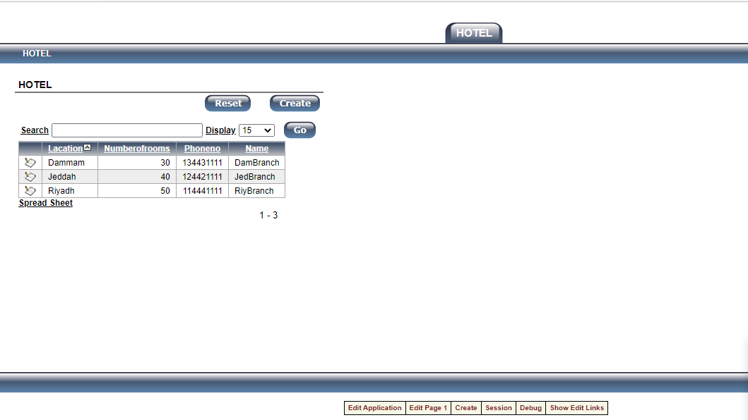

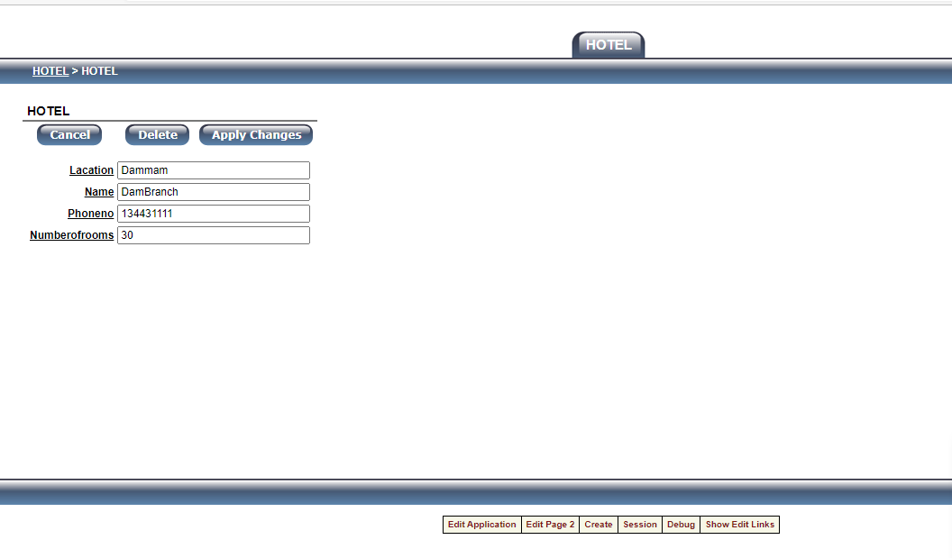

changing phoneno

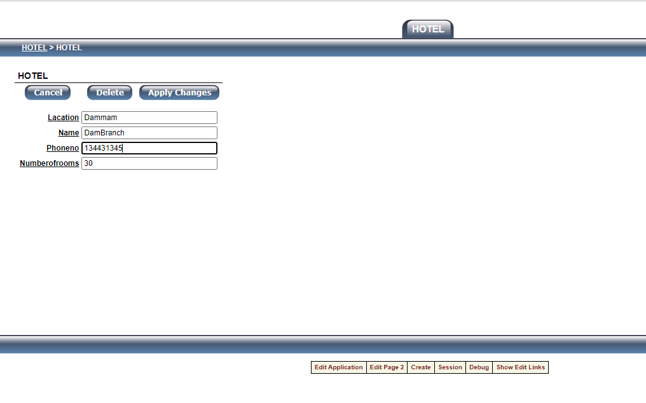

Phoneno has been changed !

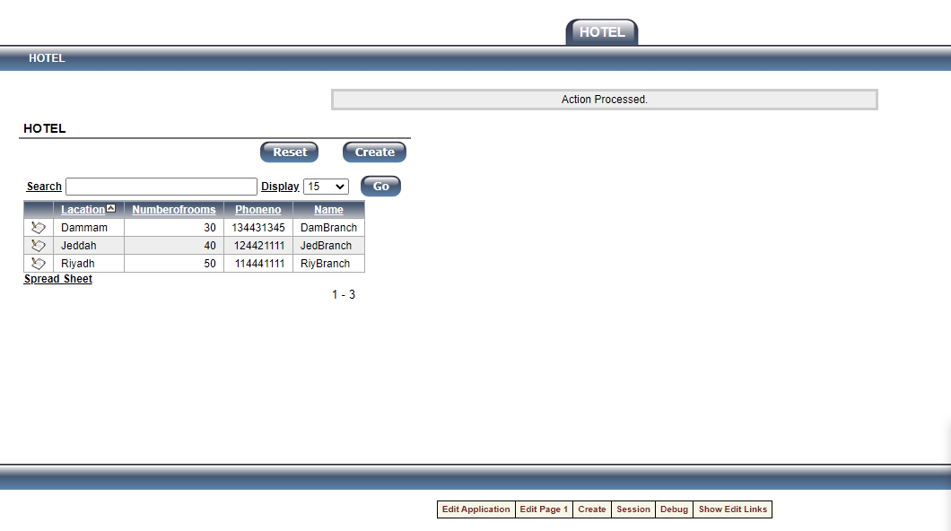

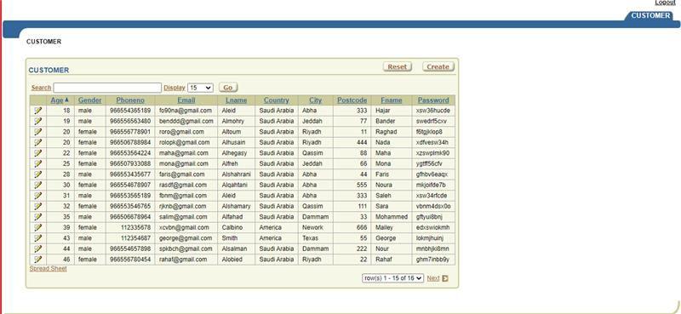

Change age

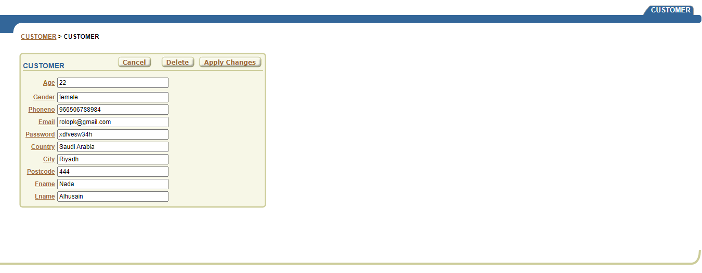

After:

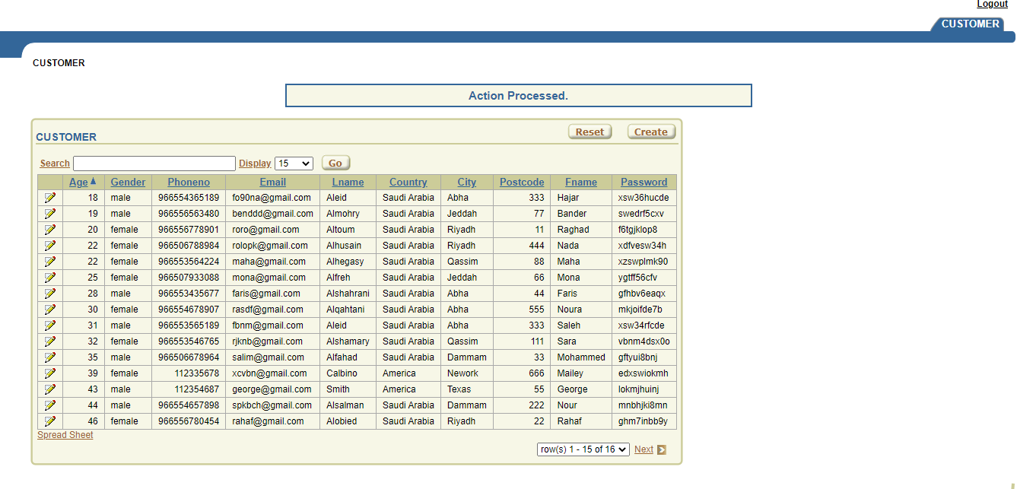

Change phone + age + email

